ADVANCED SOFTWARE SERVICES, INC
TOUCH SCREEN USER MANUAL

Title Page Title Page

Table of Contents 1 File Maintenance Shifts 43
Function Keys 2 View Shifts 44
Touch Screen Data Collection Overview 3 Machine Assigned Charge 45
Employee Password Log in 4 View Machine 46
Password Employee Log In Machine 5 Machine Sequence 47
Employee Log In Machine 6 Machine Assigned Shifts 48
Job Data Collection 7 View Machine 49
Employee Status 8 File Maintenance - Employee 50
Machine Status 9 Employee Default Rates 51
Job Number Selection 10 File Maintenance – Employee Types 52
Machine Data Collection 11
Machine Data Collection Auditing 12
Post Touch Data Machine to Advantzware Database 13
Reports – Daily Summary By Employee 14
Reports – Employees List 15
Reports – Machine Transactions List 16
Reports – Completed Machine Job List 17
Reports – Shifts List 18
Reports – Machine Assigned Charge Codes 19
Reports – Machine Assigned Shifts List 20
Reports – Employee Types List 21
File Maintenance – Employee Browse Selection 22
View Employee 23
Employee Pay Rates 24
Employee Log in / Log out 25
Employee Pay Rates 26
File Maintenance – Phone Information – Browse Phones 27
Phone Information – View Phone 28
File Maintenance – Address Information – Browse Address 29
Address Information – View Address 30
Machine Transactions – Browse Transactions 31
View Transaction 32
Employees by Machine 33
Employee Post Transactions 34
File Maintenance – Employee Transaction 35
View Employee Transactions 36
Employee Machine Transaction 37
Employee Posted Transactions 38
File Maintenance Completed Machine Jobs – Browse Mode 39
Completed Machine Jobs – View Mode 40
File Maintenance - Job Browse Sequence 41
View Sequence 42

TOUCH SCREEN
FUNCTION KEYS

The following describes the standard function buttons which can be activated with the mouse or the alternate key on your keyboard.

BRWS = The browser folder is a list of records in the file. This is functionally equivalent
to the find option of our standard package.

VIEW = View folder records provides the ability to ADD, CHANGE, DELETE and UPDATE
an individual records.

This effectively replaces the find feature of our legacy Foldware and Corrware products.

SORT BY = The selections at the bottom of the browser which will sort the list in alphabetic order.

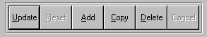

Update = Updating the current record.
Reset = Reset the current record.
Add = Add a record.
Copy = This will copy the existing record.
Delete = Delete the current record displayed on the screen. To delete an individual field, double
click on the field and press the regular delete key on the keyboard.
Cancel = Canceling the information that was entered.
Save = Save the record.


 |  |  |  |  |  |  |  |  |  |  |  |  |  |  |  |  |  |  | First – Takes you to the first record
 |  |  |  |  |  |  |  |  |  |  |  |  |  |  |  |  |  |  | Previous – Takes you back one record at a time
 |  |  |  |  |  |  |  |  |  |  |  |  |  |  |  |  |  |  | Next – Moves forward one record
 | First |  |  | Previous |  |  |  |  | Next |  |  | Last |  |  |  |  |  |  | Last – Last current record
 |  |  |  |  |  |  |  |  |  |  |  |  |  |  |  |  |  |  |  |  | F2 – Search for a record
 |  |  |  |  |  |  |  |  |  |  |  |  |  |  |  |  |  |  |  |  | F3 – List a record
 |  |  |  |  |  |  |  |  |  |  |  |  |  |  |  |  |  |  |  |  | F4 – Add notes to a record
 |  |  |  |  |  |  |  |  |  |  |  |  |  |  |  |  |  |  |  |  | F5 – Misc. fields
F2 |  |  | F3 |  | F4 |  | F5 |  |  | F6 |  |  | F7 |  |  | F8 | F9 | F12 |  |  | F6 – Browse the records
 |  |  |  |  |  |  |  |  |  |  |  |  |  |  |  |  |  |  |  |  | F7– View the records
 |  |  |  |  |  |  |  |  |  |  |  |  |  |  |  |  |  |  |  |  | F8 – Phone Information
 |  |  |  |  |  |  |  |  |  |  |  |  |  |  |  |  |  |  |  |  | F9 – Addressees
 |  |  |  |  |  |  |  |  |  |  |  |  |  |  |  |  |  |  |  |  | F12 – Exit the screen

ADVANCED SOFTWARE SERVICES, INC
TOUCH SCREEN DATA COLLECTION OVERVIEW

The touch screen data collection module is a Windows-based application that does not require a keyboard or mouse out on the plant floor, because it utilizes touch sensitive computer workstations which are respond to the heat or touch of a finger tip. The program was designed to display a numeric keypad and an alphabetic keyboard on data entry screens so that the operator can enter production data, employee password characters or a numeric job number. The keyboard and numeric keypad, which are displayed on the screen, allow the user to press the letter or number for data input purposes, hence eliminating the need for a mouse or a keyboard.

One major difference between our touch sensitive data collection module and the Advantzware data collection module is that this new program features employee tracking of hours and cost in addition to the machine time. The touch screen transactions must be posted, which are transferred the data to the Advantzware data collection module, which in turn must be posted to update the job costing system.

To speed the data entry process on the plant floor, several files must be defined with consistent default information. For example, each employee must be created in the employee file and each employees labor rates must be defined for each machine or for each shift. In addition, valid machines may be defined for each employee so that the machines will display on the workstation immediately during the data collection process.

Perhaps the greatest advantage to our new touch screen technology is the speed and ease of use for entering job data information. This is achieved because each machine has an established job sequence of operations defined in the machine file. When the operator selects a machine, the first sequence will appear immediately with the current time in hours and minutes as established on the file server computers system with A.M. and P.M. displayed just as any clock display. This saves the operator the time it takes to determine the start time and stop time of each operation as well as the time that it takes to enter the operation charge code. The only data input requirement for the operator is to enter the actual quantity produced and the actual quantity wasted during set up and running the machine. The system automatically calculates the number of hours between each successive step in the manufacturing process, thereby saving the operator time and the eliminating errors due to human calculations.

The process begins when the machine operator presses the machine button, then the job number button, which starts the set up. Next, he confirms the accuracy of the current time displayed and presses the start make ready button. Once the make ready has been completed, he then selects the job number, which causes the next operation called stop make ready to display on the screen, however he should first record the actual waste produced during set up. Next, the program will immediately prompt to start production running time and the operator simply has to press the button called start running. Once the production has been completed, the operator again will select the job and the screen will display END RUN, however the operator must push wanted the button to add quantity produced by pressing the numeric keypad displayed on the screen. In addition, the operator should also record the waste produced the production process. Whenever the touch sensitive plant floor data collection screen is active, an audit trail displays at the bottom of the screen to make fast corrections to any errors made during the process.

ADVANCED SOFTWARE SERVICES, INC
EMPLOYEE PASSWORD LOG IN
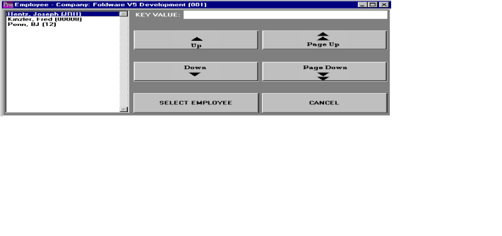

EMPLOYEE PASSWORD LOG IN

To log into a machine the employee selects his name then enters his password. He may enter his password with the keyboard displayed on the computer screen. Please note the computer keyboard displayed on the workstation may be changed in the file maintenance program. Several keyboard configurations are available including the normal computer keyboard known a querty keyboard plus an alphabetic keyboard showing the letters in alphabetic order.

The employee log in screen provides the ability for each employee to log into a machine each day. The employee must log in at least once a day to a machine and log out once a day. If an employee works on multiple machines during the day, the employee will simply log into the other machine without the requirement to log out of the existing machine. All of the daily job transactions that are recorded during the day will automatically extract the employee hours for each machine to calculate the total labor hours and the labor costs or each machine and job.

Companies that do not want to record employees individual times may assign a machine code as the employee and log in with the machine code rather than have each employee log in and out.

ADVANCED SOFTWARE SERVICES, INC
EMPLOYEE LOG IN MACHINE
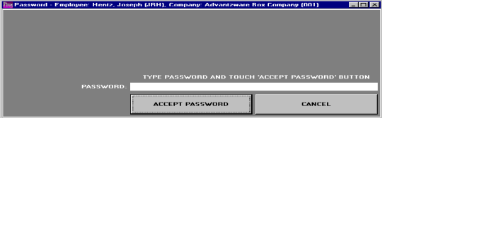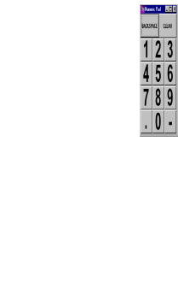

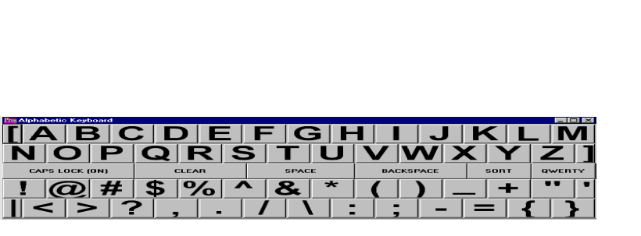

EMPLOYEE LOG IN MACHINE

Once the employee logs in by entering the correct password, the employee must select a machine. To select a machine, a list of machines will display on the workstation as defined in the employee file. Therefore, all the machines that the employee will operate during the day are listed on the workstation for his selection. If the machine is not listed on the screen he may press the ENTER machine code button, to select another machine code. When an employee moves from one machine to another machine during the day, the employee must log into a machine. Please note the employee does not have to log out of the previous machine, because the system will automatically log the employee out of the previous machine as soon as the employee logs into a new machine.

ADVANCED SOFTWARE SERVICES, INC
EMPLOYEE LOG IN MACHINE
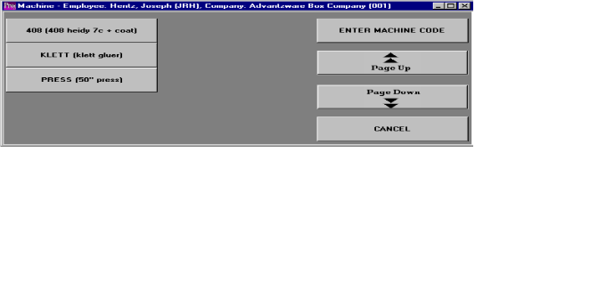

EMPLOYEE LOG IN MACHINE

Once an employee has logged onto a machine, all machine transactions recorded for each job will extract the employees labor costs and apply this labor cost to each job. Therefore, if three or four employees log into the printing press in the morning and log out at the end of the shift, they do not need to record any transactions for each job. The main operator of the printing press will record the set up, production, downtime and cleanup times for each job. The program will apply the cost of each employee to each job produced based on the length of time of each machine transaction for each job.

ADVANCED SOFTWARE SERVICES, INC
JOB DATA COLLECTION

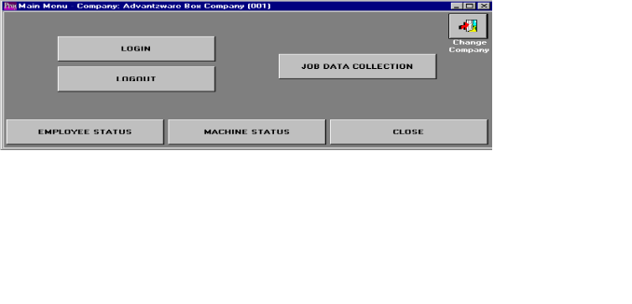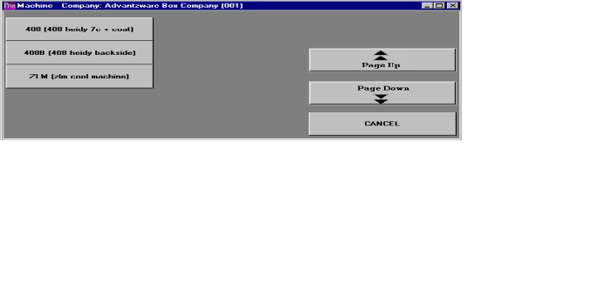

JOB DATA COLLECTION

The job data collection provides the equivalent functionality of the Advantzware data collection program, however it does not require the operator to calculate the start time, stop time or operation code. The time automatically displays and the time is automatically calculated on the operator's screen for each operation step a machine performs. The operator records each machine operation step including the beginning of make ready, ending of make ready, beginning production, ending of production running, start and stop times for cleanup and any downtime. The Advantzware data collection requires both steps to be completed before entering the transaction, whereas the touch screen technology allows the operator to record both the start and stop process separately without calculating the hours and minutes for each process.

To start adding machine data, just press the job data collection button followed by the machine where the operator will begin his work. A list of machine buttons will appear representing the machines, which the employees have selected via the log in process. The operator may press the page up or the page down button to show additional machines. At any time, the operator may press the CANCEL button or the EXIT button at the top of the right hand corner of the screen to exit the current screen.

ADVANCED SOFTWARE SERVICES, INC
EMPLOYEE STATUS BUTTON

EMPLOYEE LOG IN MACHINE

Once employees log into a machine, the EMPLOYEEE STATUS button may be utilized to view all the
status of an employee.

Once the EMPLOYEE BUTTON is pressed, a list of employees that are currently logged into a machine are shown on the screen. Press the UP, DOWN, PAGE UP, PAGE DOWN, CANCEL or SELECT EMPLOYEE button to navigate through the list of employees.

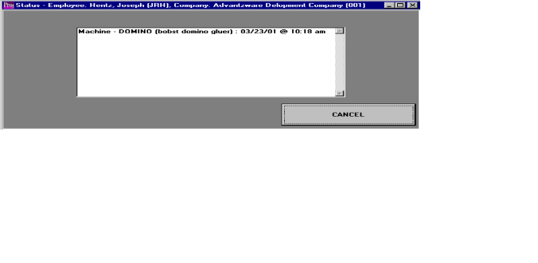

Once the employee is selected, the current machine that the employee is running is listed along with the time and date that the current transaction started.

ADVANCED SOFTWARE SERVICES, INC
MACHINE STATUS

Once employees log into a machine, the MACHINE STATUS button may be utilized to view all the status of all the employees currently running a particular machine.

Once the MACHINE STATUS button is pressed, a list of machines that are currently running are shown on the screen. Press the PAGE UP, PAGE DOWN, CANCEL or SELECT MACHINE button to navigate through the list of machines.

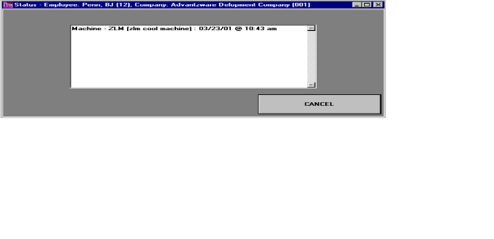

Once the Machine is selected, the current list of employees working on the machine are displayed along with the time and date that each employee started work on that machine.

ADVANCED SOFTWARE SERVICES, INC
JOB NUMBER SELECTION

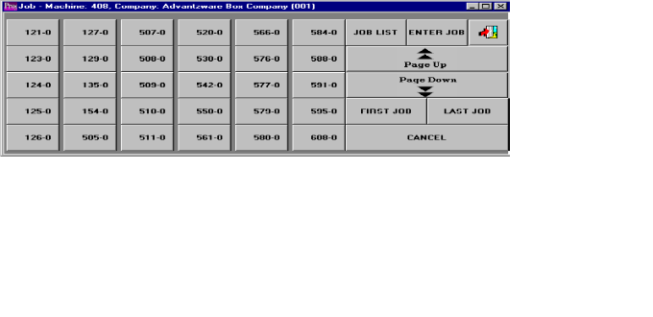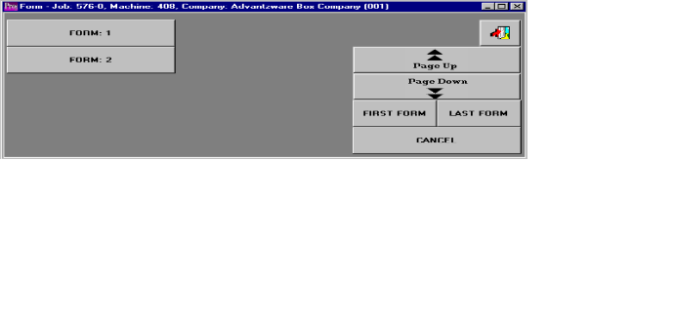

JOB NUMBER SELECTION

Once the operator has selected a machine, a list of open JOB NUMBER buttons for this machine center will display on the screen. If the desired job is not shown on the screen, The operator may press the PAGE DOWN or the PAGE UP button to select more jobs. As an alternative, the operator may press the JOB LIST button, which will show a numeric list of all jobs for selection by the operator. Lastly, the operator may press the ENTER job button and enter the job number with the numeric keypad buttons displayed on the workstation. Once the operator has selected the job number, the program will proceed directly to the data collection screen. For a folding carton combination job or for a corrugated set job, the system will prompt with a FORM NUMBER button, which represents the sheet size for each form which is being currently being converted. It is critical that the operator select the correct FORM button, otherwise the job costing and production reports will be inaccurate. If the machine selected is for a printing press for a job with multiple printing passes, the program will prompt with PASS NUMBER button. For large combination jobs, the form number may not be displayed on the screen, therefore the operator may press of the FIRST FORM button or the LAST FORM button to show more form numbers for this particular job number. At any time during the process, the operator may press the EXIT WINDOW button at the top right hand corner of the computer screen for the CANCEL button to abort the current transaction screen.

ADVANCED SOFTWARE SERVICES, INC
MACHINE DATA COLLECTION

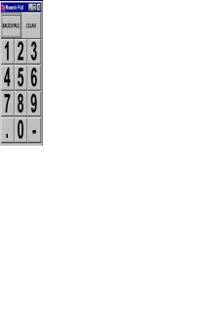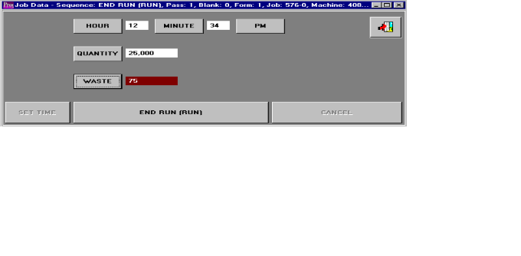

MACHINE DATA COLLECTION

Once the machine, job number and form number have been selected, the first operation sequence for this machine will appear on the machine data collection screen. The manufacturing sequence should be defined in the machine file, therefore the normal manufacturing steps of set up, production run and subsequent cleanup are pre-defined so that the operator need not waste time entering these operation codes during machine data collection.

The top of the machine data collection screen shows the machine number, job number, the current manufacturing step, the form number as well as the pass number for jobs with multiple printing presses passes. If any information at the top of the screen is incorrect, the operator should press the EXIT button to exit the screen and select the proper job information.

The middle part of the machine data collection screen shows the current time of the day represented by the HOUR, MINUTE AND AM/PM buttons; the QUANTITY produced button and the WASTE button. The current time of the day will appear automatically from the time set on the computer network server, however the operator may press any of the time buttons to change either the hours or minutes. When first processing a job the ACCEPT MAKE READY button will appear at the bottom of the screen, therefore the operator will simply press is this button to start make ready. Once make ready has been finished, the END MAKE READY button will appear, however the operator should first press the WASTE button to enter the quantity of waste produced during this process. Once the END MAKE READY button has been pressed the START RUN button immediately appears so that pressing this button will immediately begin production run time. Once the production has been finished, the END RUN button will appear so that the operator can enter the quantity produced as well as the run spoilage quantity. Pressing the END RUN button completes the manufacturing process for this machine, unless the CLEANUP button displays to record the start and stop times for wash up and cleanup.

The right side of the screen shows a numeric keypad with buttons for each number to enter the production quantity, set up waste and run spoilage. In addition a BACKSPACE and CLEAR button are available for text editing the production data.

The bottom of the machine data collection has three buttons called SET TIME, OPERATION STEP and CANCEL. The operation step button will display either starting or ending MAKE READY, RUN or CLEANUP. This middle button on the bottom of the screen must be pressed to complete any other manufacturing steps. After processing any of the manufacturing steps, the operator should exit the machine data collection screen. If the operator does not exit this screen, he should press the SET TIME button to update the current time displayed on the screen before completing the next manufacturing procedure.

Many plant floors will share a touch sensitive computer screen, therefore once the current machine operation step has been completed, the machine operator should press the EXIT button to exit the screen. This will allow another operator to utilize the workstation to reenter the data for another machine.

ADVANCED SOFTWARE SERVICES, INC
MACHINE DATA COLLECTION AUDITING

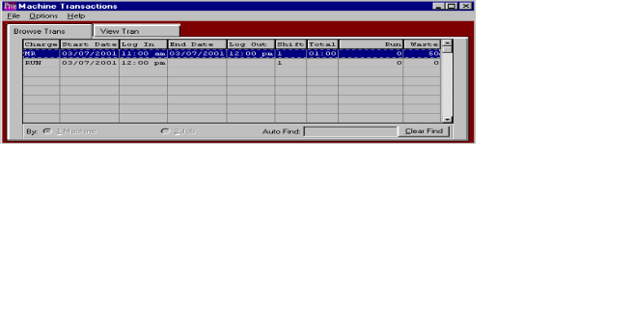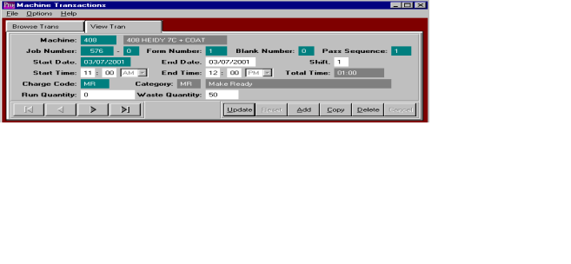

MACHINE DATA COLLECTION AUDITING

The bottom of the machine data collection screen shows the audit trail of all machine transactions performed for this job, which is represented by a MACHINE BROWSER. This browser shows the labor charge code, starting date, log in time, date finished, log out time, shift, total hours, quantity produced and quantity of waste for each process. The operator may change the data of any transaction by double clicking any highlighted transaction. This will transfer the operator to the view transaction screen, which will allow the operator to update the transaction. This screen also provides the ability to add, copy, delete, or view additional transactions by using the UPDATE, ADD, COPY, OR DELETE buttons, respectively. To add or change any information on the view transaction screen, simply press the data field that requires modification. Once the data has been changed, the operator must press the SAVE Button to record the corrections.

ADVANCED SOFTWARE SERVICES, INC
POST TOUCH DATA MACHINE DATA TO ADVANTZWARE DATABASE

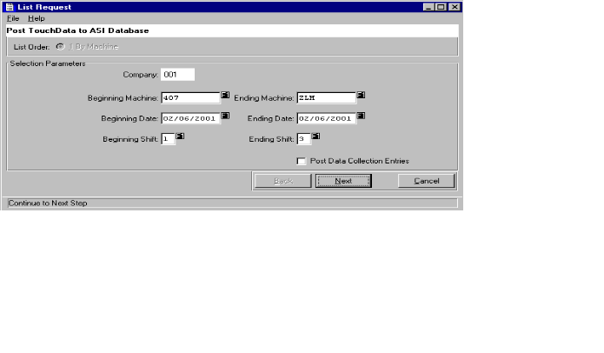

POST TOUCH DATA MACHINE DATA TO ADVANTZWARE DATABASE

Once the machine data collection has been entered and the audit trail analyzed for accuracy, the job information must be posted in order to transfer to the Advantzware database. Once posted the transactions are removed from the active audit trail, however the posted transactions may be reviewed at any time via the posted transaction history file.

Machine transactions may be posted by company number, for a specific machine, a range of machines, for a range of dates and a range of shifts. The posting report may be run without updating the Advantzware database by not marking the box titled POST DATA COLLECTIONS ENTRIES. When the supervisor has verified the accuracy of the machine data collection, the transactions should be posted by checking the box title POST DATA COLLECTION ENTRIES.

This will transfer the machine transactions to the Advantzware plant data collection file, however this file may be reviewed or updated prior to posting to the Job Cost files. This will not move the employee transactions to the Advantzware database; therefore this history must be reviewed in the employee transaction files of the Touch Sensitive Data Collection module.
ADVANCED SOFTWARE SERVICES, INC
REPORTS – DAILY SUMMARY BY EMPLOYEE

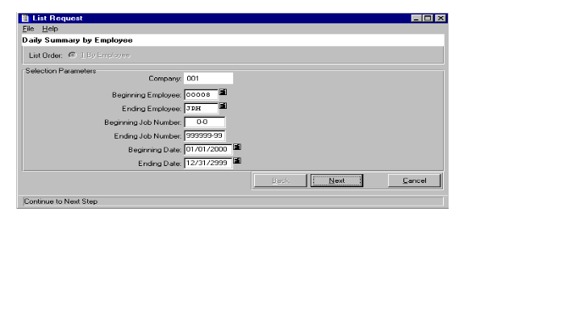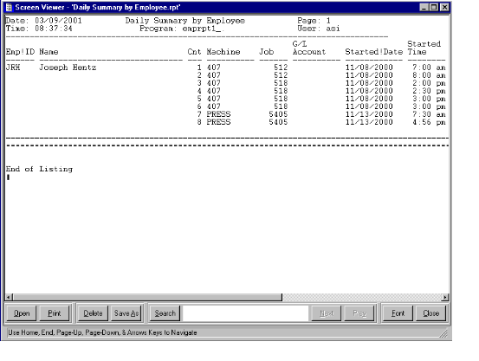

REPORTS - DAILY SUMMARY BY EMPLOYEE

The daily summary by employee report should be printed to view the employee time cards including the beginning and ending time for each shift, as well as the starting and ending time or each job. The report may be run for any company, employee, job and a range. The report shows the date and time of each employee including the employee number, employee name, machine code, general ledger expense account number, transaction date and the time started.

The report may be printed to the screen, to any printer on the network or to a file. The SAVE AS button at the bottom of the screen may be used to save the report with any filename that the user chooses. The FONT button will allow the user to select which size letters to print the report, however the report will print in alignment when using the eight point font. The SEARCH button will provide a look up capability for any string of text on the print out of the report. To exit the report, press the X at the top of the right hand corner of the screen or press the CLOSE button at the bottom of the screen.

ADVANCED SOFTWARE SERVICES, INC
REPORTS - EMPLOYEES LIST

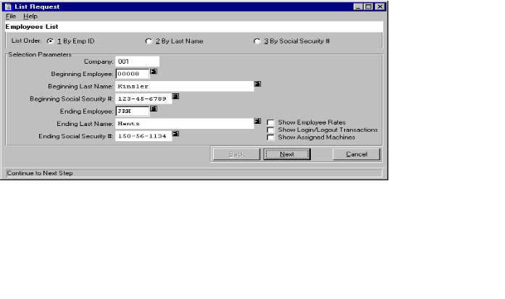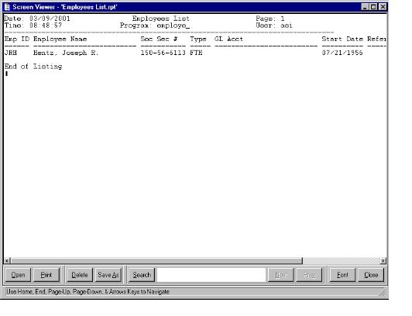

REPORTS - EMPLOYEE LIST

The employee list report should be printed to view the current list of employees. The report may be run for any company, an employee number range, employee last name range or social security number range. The report has additional printing options which are enabled by checking the boxes in the lower right hand corner of the screen titled; show employee rates, show log in/ log out transactions, show assigned machines. By selecting one of these boxes, the report will list the requested information. To show the print selections on the report, the user must select the parameter button. The top of the report shows the date and time that the report was run, report name, the program name, the user ID who ran the report and the page number. The detail portion of the report shows the employee number, employee's name, employee type, general ledger account number, the date the employee started and any reference.

The report may be printed to the screen, to any printer on the network or to a file. The SAVE AS button at the bottom of the screen may be used to save the report with any filename that the user chooses. The FONT button will allow the user to select which size letters to print the report, however the report will print in alignment when using the eight point font. The SEARCH button will provide a look up capability for any string of text on the print out of the report. To exit the report, press the X at the top of the right hand corner of the screen or by pressing the CLOSE button of the bottom of the screen.

ADVANCED SOFTWARE SERVICES, INC
REPORTS - MACHINE TRANSACTIONS LIST

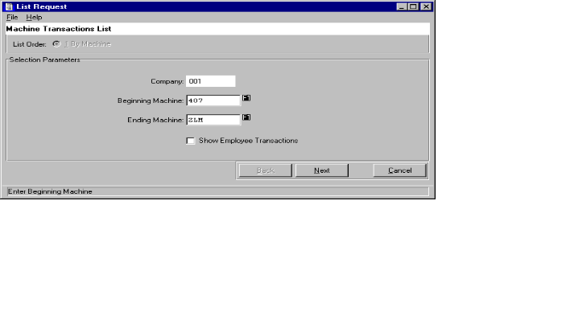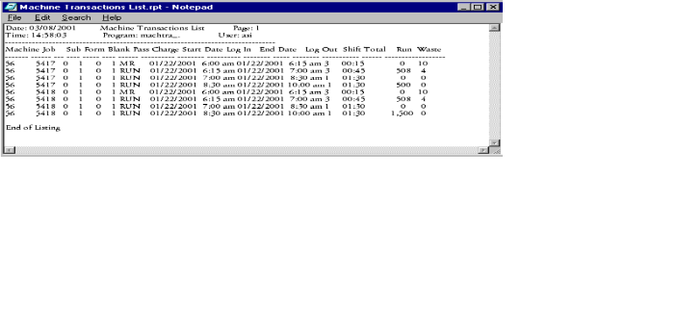

REPORTS - MACHINE TRANSACTIONS LIST

The Machine Transactions List shows a daily summary by machine transactions, which have not been posted to the Advantzware database. The report may be printed for any company and for any range of machines. In addition, the report will also list the details of the employee transactions. To show the employee transactions, the user must mark the box called show employee transactions on the print screen. The report could be printed to view only the machines daily transactions. To show the print selections on the report, the user must select the parameter button. The top of the report shows the date and time that the report was run, report name, the program name, the user ID who ran the report and the page number. The detail portion of the report shows the machine number, job number, form number, printing pass number, starting date, log in time, ending date, log out time, shift number, total hours, quantity produced while running and the quantity wasted.

The report may be printed to the screen, to any printer on the network or to a file. The SAVE AS button at the bottom of the screen may be used to save the report with any filename that the user chooses. The FONT button will allow the user to select which size letters to print the report, however the report will print in alignment when using the eight point font. The SEARCH button will provide a look up capability for any string of text on the print out of the report. To exit the report, press the X at the top of the right hand corner of the screen or by pressing the CLOSE button of the bottom of the screen.

ADVANCED SOFTWARE SERVICES, INC
REPORTS - COMPLETED MACHINE JOB LIST

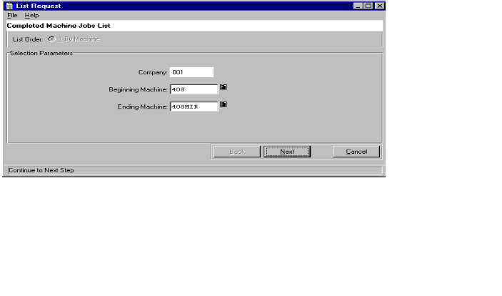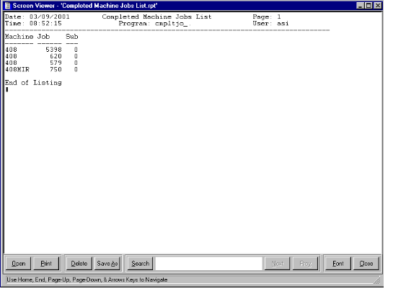

REPORTS - COMPLETED MACHINE JOB LIST

The Completed Machine Job List shows a list of job numbers with the machine number representing completed operations. The report may be printed for any company or any range of machines. To show the print selections on the report, the user must select the parameter button. The top of the report shows the date and time that the report was run, report name, the program name, the user ID who ran the report and the page number. The detail portion of the report shows the machine number and the job number.

The report may be printed to the screen, to any printer on the network or to a file. The SAVE AS button at the bottom of the screen may be used to save the report with any filename that the user chooses. The FONT button will allow the user to select which size letters to print the report, however the report will print in alignment when using the eight point font. The SEARCH button will provide a look up capability for any string of text on the print out of the report. To exit the report, press the X at the top of the right hand corner of the screen or by pressing the CLOSE button of the bottom of the screen.

ADVANCED SOFTWARE SERVICES, INC
REPORTS - SHIFTS LIST

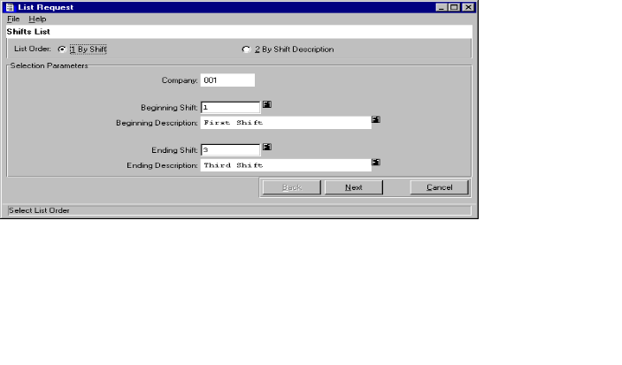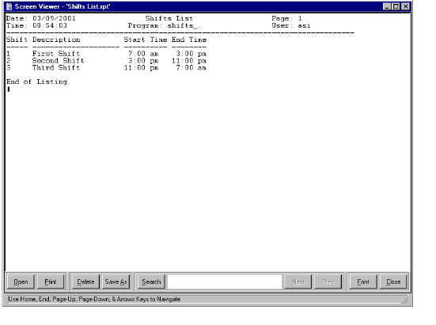

REPORTS - SHIFTS LIST

The Shifts List shows a list of shift numbers, shift description and shift times, which have been established for all machines in the plant. The shifts are created in the shift file, whereby each machine can have its own shift times, hence different departments may have different start and stop times for each shift. The report may be printed for any company or any range of shifts. To show the print selections on the report, the user must select the parameter button. The top of the report shows the date and time that the report was run, report name, the program name, the user ID who ran the report and the page number. The detail portion of the report shows the shift number, shift description, start time and ending time.

The report may be printed to the screen, to any printer on the network or to a file. The SAVE AS button at the bottom of the screen may be used to save the report with any filename that the user chooses. The FONT button will allow the user to select which size letters to print the report, however the report will print in alignment when using the eight point font. The SEARCH button will provide a look up capability for any string of text on the print out of the report. To exit the report, press the X at the top of the right hand corner of the screen or by pressing the CLOSE button of the bottom of the screen.

ADVANCED SOFTWARE SERVICES, INC
REPORTS - MACHINE ASSIGNED CHARGE CODES

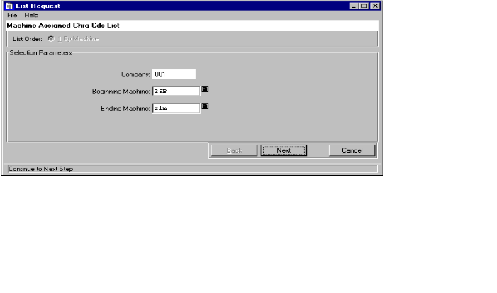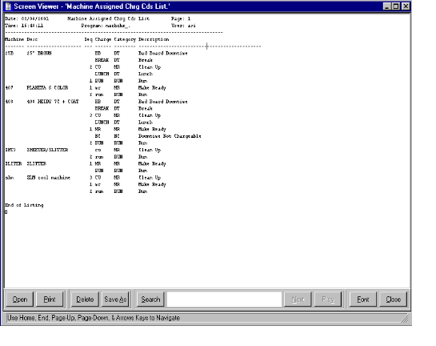

REPORTS - MACHINE ASSIGNED CHARGE CODES

The machine assigned charge code report shows all of the assigned labor transaction codes, which each machine will record during the production process. The report may be printed for any company or any range of machines. To show the print selections on the report, the user must select the parameter button. The top of the report shows the date and time that the report was run, report name, the program name, the user ID who ran the report and the page number. The detail portion of the report shows the machine number, machine name, sequence number, charge code, charge category and description of the charge. The charge code category included are make ready, run, down time charged to a job and down time not charge to a job, which are created by Advanced Software only in the Advantzware database. The labor charge codes are defined in the machine charge code file of the Advantzware system, however unique charge codes may be added for each machine in the touch screen file maintenance machine assigned charge code file.

The report may be printed to the screen, to any printer on the network or to a file. The SAVE AS button at the bottom of the screen may be used to save the report with any filename that the user chooses. The FONT button will allow the user to select which size letters to print the report, however the report will print in alignment when using the eight point font. The SEARCH button will provide a look up capability for any string of text on the print out of the report. To exit the report, press the X at the top of the right hand corner of the screen or by pressing the CLOSE button of the bottom of the screen.

ADVANCED SOFTWARE SERVICES, INC
REPORTS - MACHINE ASSIGNED SHIFTS LIST

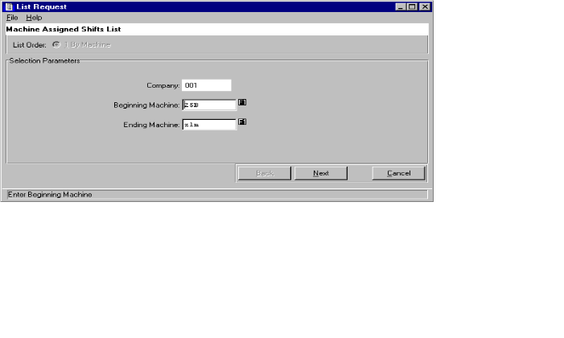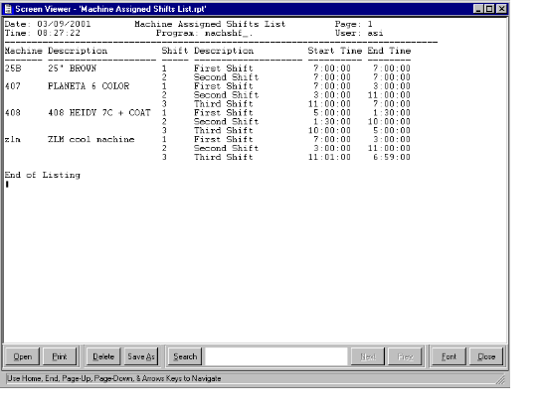

REPORTS - MACHINE ASSIGNED SHIFTS LIST

The Shifts List shows a list of assigned shift numbers for each machine including the shift description and shift times, which have been established for the machine. The shifts are created in the shift file, whereby each machine can have its own shift times, hence different departments may have different start and stop times for each shift. The report may be printed for any company or any range of machines. To show the print selections on the report, the user must select the parameter button. The top of the report shows the date and time that the report was run, report name, the program name, the user ID who ran the report and the page number. The detail portion of the report shows the machine number, machine description, shift number, shift description, start time and ending time.

The report may be printed to the screen, to any printer on the network or to a file. The SAVE AS button at the bottom of the screen may be used to save the report with any filename that the user chooses. The FONT button will allow the user to select which size letters to print the report, however the report will print in alignment when using the eight point font. The SEARCH button will provide a look up capability for any string of text on the print out of the report. To exit the report, press the X at the top of the right hand corner of the screen or by pressing the CLOSE button of the bottom of the screen.

ADVANCED SOFTWARE SERVICES, INC
REPORTS - EMPLOYEE TYPES LIST

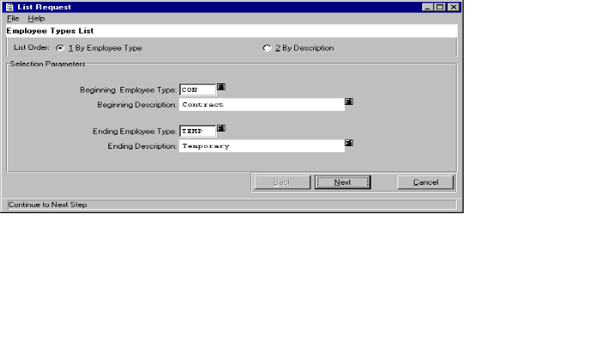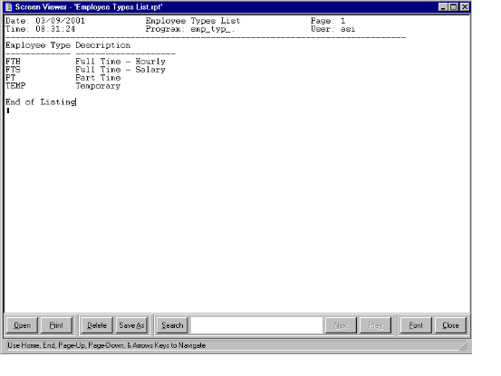

REPORTS - EMPLOYEE TYPES LIST

The employee list report should be printed to view the current list of employee types. The employee types are created in the employee type file for creating types such as full-time hourly, full-time salary, part time and temporary. The report may be run for any company, an employee type range or an employee type description range. To show the print selections on the report, the user must select the parameter button. The top of the report shows the date and time that report was run, the report name, program name, the user ID who ran the report and the page number. The detail portion of the report shows the employee type and employee type description.

The report may be printed to the screen, to any printer on the network or to a file. The SAVE AS button at the bottom of the screen may be used to save the report with any filename that the user chooses. The FONT button will allow the user to select which size letters to print the report, however the report will print in alignment when using the eight point font. The SEARCH button will provide a search capability for any string of text on the print out of the report. To exit the report, press the X at the top of the right hand corner of the screen or by pressing the CLOSE button of the bottom of the screen.

ADVANCED SOFTWARE SERVICES, INC
FILE MAINTENANCE – EMPLOYEE BROWSE SELECTION
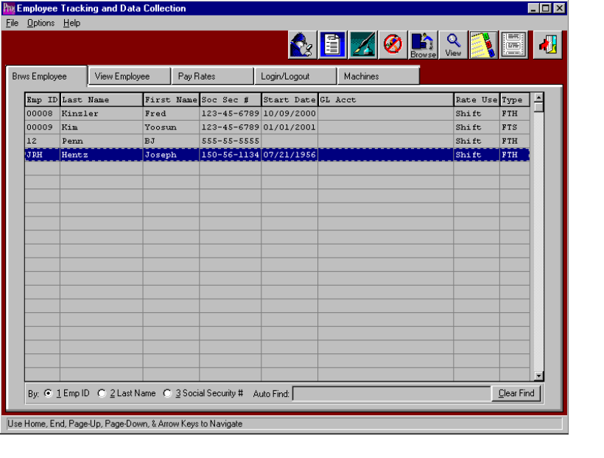

EMPLOYEE BROWSER

Prior to adding employees, the default employee rates, default company shifts and default hourly labor rates should be created to speed the data entry process. The Employee Browser shows a list of employees which may be sorted by employee number, last name or social security number. Once an employee record is highlighted on the screen, simply double click with your mouse or press the ENTER KEY to view or change the employee data. The browser is very similar to the F5 function key which Advantzware users may be familiar with using. To sort by the employee ID, last name or social security number, simply check the appropriate field at the bottom of the browser and the list will be resorted in that order. To find a particular employee, the AUTO FIND block at the bottom of the browser provides an alpha numeric search capability by typing a few characters and pressing the ENTER KEY. The browser shows the employee ID, last name, first name, Social Security number, starting date, General ledger account number, the employee rate shift usage and the employee type.

The icons at the top of the browser provided additional capabilities. The F2 key, represented by the icon of the little man with a magnifying glass provides a search capability by an employee. The F3 key, represented by an icon of a turning page will provide a list of employee, which may be printed or viewed on the screen. The F4 Key, represented by the icon with the fountain pen provides notes for each employee record. Each note records the user's initials the date the note was created, description of the note and a full-page of text for each note. Unlimited notes may be defined for each record. The F5 Key provides for miscellaneous fields. The F6 key or Browse icon will provide an immediate access to the browser by employee number. The F7 key or View icon provides an employee list as a quick reference list. The F8 key, represented by an icon of a folder with three tabs provides a phone list for each employee. The F9 key, represented by the icon with perforated mailing labels provides an address list for each employee. The F12 key, represented by the open door is the equivalent of escape or exit.

The other folders listed on the employee browser screen provide the ability to add, change, delete and copy employee's, a rate log in times, log now times and machines which the employee is authorized to operate.

ADVANCED SOFTWARE SERVICES, INC
FILE MAINTENANCE – EMPLOYEE BROWSE SELECTION – VIEW EMPLOYEE

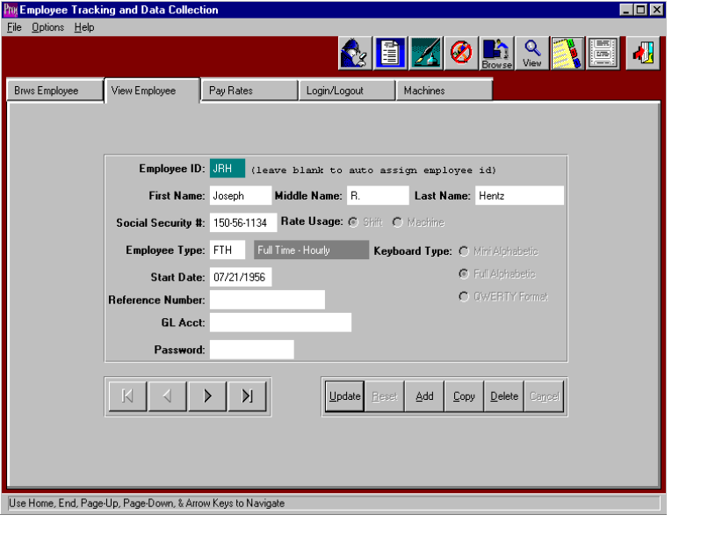

EMPLOYEE BROWSER - VIEW EMPLOYEE

One major difference between our touch sensitive data collection module and the Advantzware data collection module is that this new program features employee tracking of hours and cost in addition to the machine time, which both products record. If your company does not want to track employee hours, then create an employee equal to the machine operation so that only one employee which will log into the machine code. There should be at least one employee per machine.

To add, change, delete, or view an employee, the folder called VIEW EMPLOYEE must be selected. To add a new employee, click the ADD button or press alternate and letter A together. When adding a new employee, the user must assign the employee number. To move from field to field, as with all Windows-based programs, the TAB key should be utilized. The employee start date will default to today's date, but may be changed as required. The F1 KEY provides a look up to find a date by utilizing at electronic calendar. Press the UPDATE button to update an existing first name, last name, middle name, social security number, pay rate usage, employee type, keyboard type, start date of employment, reference number, general ledger expense account number and password. To copy an employee, press the COPY button, then change the information for the new employee. To delete an existing employee, select the employee from the browser screen, the press the DELETE button. The left and right ARROW buttons at the bottom on the screen will search for the first employee, the previous employee, next employee and last employee respectively. The ENTER key or the SAVE button are used to save the new employee information.

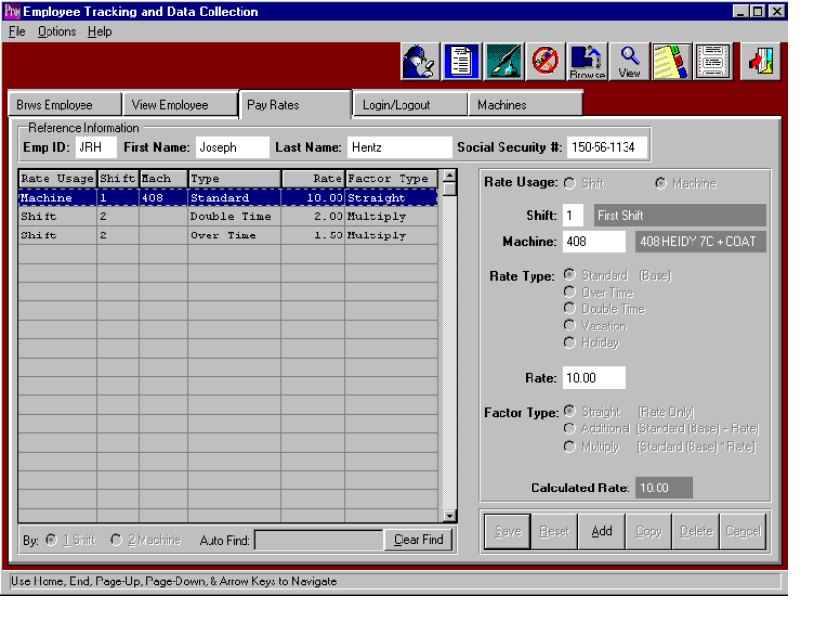ADVANCED SOFTWARE SERVICES, INC
FILE MAINTENANCE – EMPLOYEE BROWSE SELECTION – EMPLOYEE PAY RATES

EMPLOYEE BROWSER - PAY RATES FOLDER

To add, change, delete, or view an employee's hourly or salary pay rates, the folder called PAY RATES must be selected after selecting an employee. The employees pay rate browser will list the existing pay rates showing the rate usage (i.e. by machine or shift), shift number, machine code, rate type, hourly rate and factor type description. To add new employee pay rates, click the ADD button or press the ALTERNATE key and letter A simultaneously. To move from field to field, as with all Windows-based programs, the TAB key should be utilized. Press the UPDATE button to modify an existing employee pay rate selected on the pay rate browser. To copy an employee pay rate, press the COPY button, then change the information for the new employee. To delete an existing employee pay rate, select the employee from the browser screen, the press the DELETE button. The left and right ARROW buttons at the bottom on the screen, will search for the first pay rate, the previous pay rate, next pay rate and last pay rate. The ENTER key or the SAVE button are used to save the pay rate.

When adding or updating an hourly pay rate, many selections are available to help calculate the employees pay rate. The first field on the screen is the rate usage, which determines if the pay rate is for a particular machine or the pay rate is for the entire shift. If the employee has only one hourly rate for all machines that he operates, the rate usage should be set to shift. If the employee is paid different hourly rates depending on the machine, the rate usage should be set to machine. The shift field must be a valid shift defined in the shift file, therefore the F1 key may be used to display the valid shifts. The machine code is required only if the rate usage field is set to machine, whereby the employee's hourly rate will be defined for each particular machine. The rate type field is used to differentiate different hourly rates for the same employee. Available options are a standard rate, overtime rate, double time rate, vacation rate and a holiday rate. The hourly rate field is the dollar amount paid to the employee for the selected rate type. The F1 key on the rate field may be used to help calculate the hourly rate by displaying a worksheet browser. The user may enter the total dollar amount paid to the employee on a yearly, semi annual, quarterly, monthly, biweekly, weekly or daily basis. When the OK button is selected, total dollar amount will be divided by the payment period chosen to determine the hourly rate. For example, we could add $800 dollars in the amount field, click the weekly pay basis, press the OK and the rate of $20 per hour would transfer to the hourly rate field. The factor type field defines the multiplication factor for the pay rate. The options include a standard rate, additional rate and multiplied rate. The standard rate is equal to the hourly rate, the additional rate is a dollar amount added a standard rate and multiplied rate is the factor multiplied by the standard rate. The net result is the calculated rate which is used for costing the man hours labor times.

ADVANCED SOFTWARE SERVICES, INC
FILE MAINTENANCE – EMPLOYEE BROWSE SELECTION – LOG IN/LOG OUT

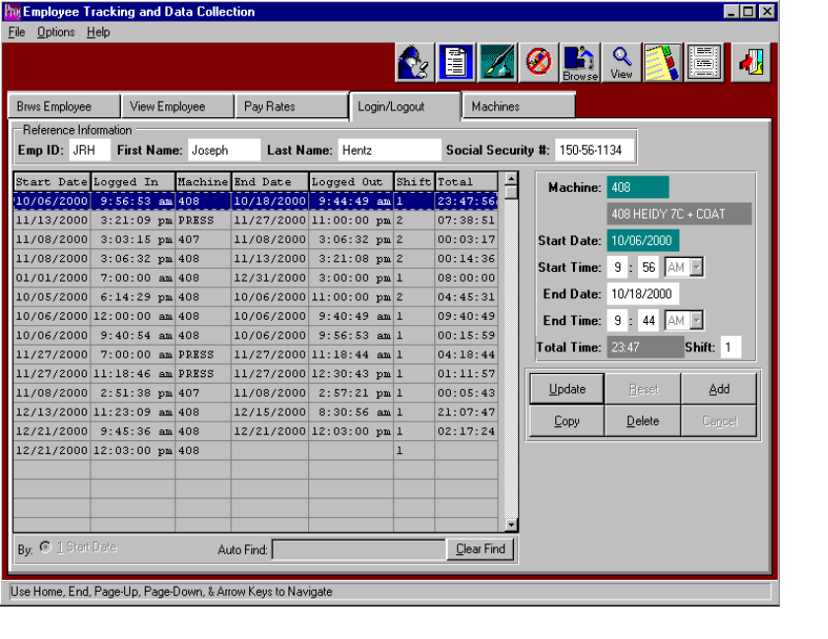

EMPLOYEE BROWSER - EMPLOYEE LOG IN / LOG OUT

To add, change, delete, or view an employee's log in and log out history, the folder called LOG IN/LOG OUT must be selected after selecting an employee. The employees log in/log out browser will list the current machine transactions for an individual employee. The browser shows the employee ID, first name, last name, and social security number as the reference information at the top of the browser. The detail section of the browser shows a list of machine transactions for the employee showing the transactions start date, log in time, machine code, ending date, time log out, shift and total hours for that machine transaction for that employee.

To add new employee transactions, click the ADD button or press the ALTERNATE key and letter A simultaneously. To move from field to field, as with all Windows-based programs, the TAB key should be utilized. Press the UPDATE button to modify an existing employee’s transaction selected on the Log in / Log out browser. To copy an employee transaction, press the COPY button, then change the information for the new employee. To delete an existing employee transaction, select the employee from the employee browser screen, then select the transaction from the log in browser, then press the DELETE button. The left and right ARROW buttons at the bottom on the screen will search for the first employee transaction, the previous employee transaction, next employee transaction and last employee transaction. The ENTER key or the SAVE button are used to save the log in / log out time. When updating a transaction or adding a transaction, the starting date, starting time, ending date, ending time and shift number may be changed.

ADVANCED SOFTWARE SERVICES, INC
FILE MAINTENANCE – EMPLOYEE BROWS SELECTION – EMPLOYEE PAY RATES
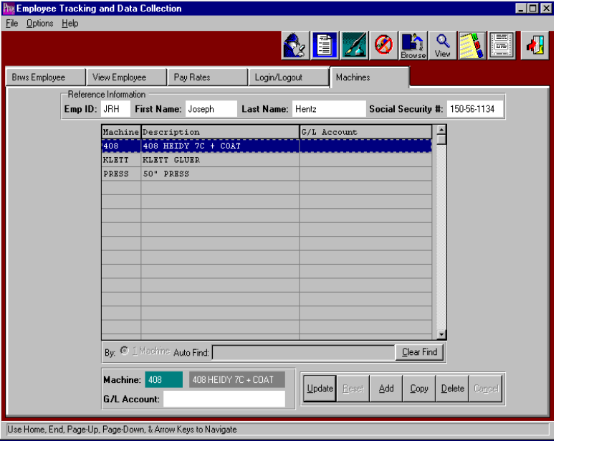

EMPLOYEE BROWSER - EMPLOYEE MACHINES FOLDER

The employee machine folder allows definition of machine's which the employee will operate on the plant floor so that the machine buttons are available when posting production. To add, change, delete, or view an employee's machine list, the folder called MACHINE must be selected after selecting an employee. The employee's Machine browser will list the current machine that an individual employee may operate during the day. The browser shows the employee ID, first name, last name, and social security number as the reference information at the top of the browser. The detail section of the browser shows a list of machines for the employee showing the machine care, machine description and general ledger expense account number for that employee.

To add new machines, click the ADD button or press the ALTERNATE key and letter A simultaneously. To move from field to field, as with all Windows-based programs, the TAB key should be utilized. Press the UPDATE button to modify an existing machine selected on the machine browser. To copy a machine, press the COPY button, then change the information for the new machine. To delete an existing machine, select the employee from the employee browser screen, then select the transaction from the machine browser, then press the DELETE button. The left and right ARROW buttons at the bottom on the screen will search for the first machine, the previous machine, next employee machine and last machine. The ENTER key or the SAVE button are used to save the machine record. When updating a machine or adding a machine, the machine code, description and General ledger expense account may be updated.

ADVANCED SOFTWARE SERVICES, INC
FILE MAINTENANCE – PHONE INFORMATION – BROWSE PHONES

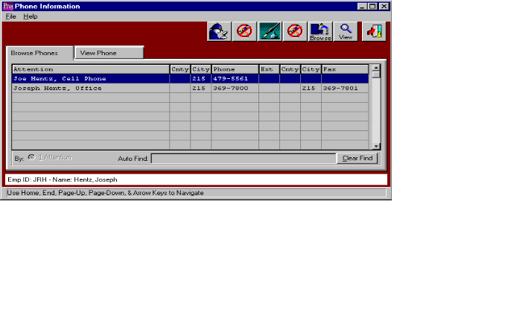

EMPLOYEE BROWSER - F8 KEY, BROWSE PHONE DIRECTORY

The Phone Browser shows a directory of employee's phone numbers, which are sorted the attention line. Once an employee record is highlighted on the View Employee screen, simply press the F8 KEY or click the booklet icon with three tabs. The browser is very similar to the F5 function key which Advantzware users may be familiar with using. To find a particular phone number, the AUTO FIND block at the bottom of the browser provides an alpha numeric search capability by typing a few characters and pressing the ENTER KEY. The browser shows the employees phone description, country code, area code (city code), phone number, extension, fax country code, fax area code, fax phone number and fax extension. The F12 key, represented by the open door is the equivalent of escape or exit.

ADVANCED SOFTWARE SERVICES, INC
FILE MAINTENANCE – PHONE INFORMATION – VIEW PHONE
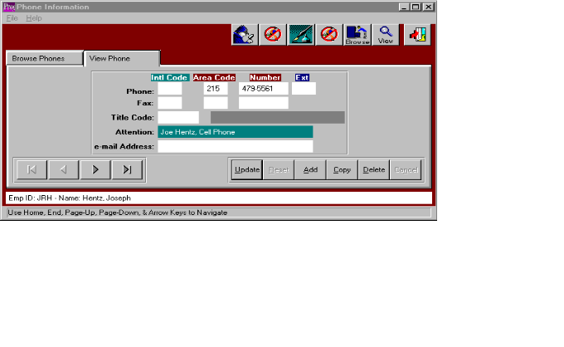

EMPLOYEE BROWSER - F8 KEY, VIEW PHONE

To add, change, delete, view an employee number or fax number in the employees phone directory, first select the employee from the Employee Browser. Next, press the F8 key or click the booklet icon with three tabs, then click the ADD button or press alternate and letter A together. To move from field to field, as with all Windows-based programs, the TAB key should be utilized. Many phone numbers may be created for an individual employee such as his home number, doctor's phone number, emergency phone number and more. An existing employee phone number may be changed, by pressing the UPDATE button. To copy a number, press the COPY button, then change the information for the new employee phone number. To delete an existing employee number, select the employee from the browser screen, then press the DELETE button. The left and right ARROW buttons at the bottom on the screen, will search for the first number, the previous number, next number and last number respectively. The ENTER key or the SAVE button are used to save the employee phone numbers.

ADVANCED SOFTWARE SERVICES, INC
FILE MAINTENANCE – ADDRESS INFORMATION – BROWSE ADDRESS

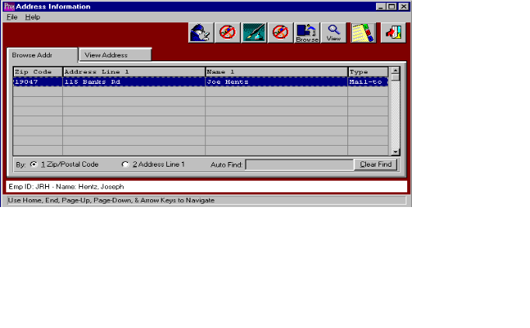

EMPLOYEE BROWSER - F9 KEY, BROWSE ADDRESS

The Employee Address Browser shows a directory of employee's addresses. Once an employee record is highlighted on the View Employee screen, simply press the F9 key, or click the icon with the perforated mailing labels. This provides an address list for each employee. The browser is very similar to the F5 function key which Advantzware users may be familiar with using. To sort by the address, simply check the appropriate field at the bottom of the browser and the list will be resorted in that order. To find a particular address, the AUTO FIND block at the bottom of the browser provides an alpha numeric search capability by typing a few characters and pressing the ENTER KEY. The browser shows the employees first contact name, second contact name, address one, address two, city, state, zip or postal code, country and the address type. For each address the user may select a valid address type including built to, mail to, ship to, business, delivery or other. The address types may provide additional sort options and reporting options in the future. The F12 key, represented by the open door is the equivalent of escape or exit.

ADVANCED SOFTWARE SERVICES, INC
FILE MAINTENANCE – ADDRESS INFORMATION – VIEW ADDRESS

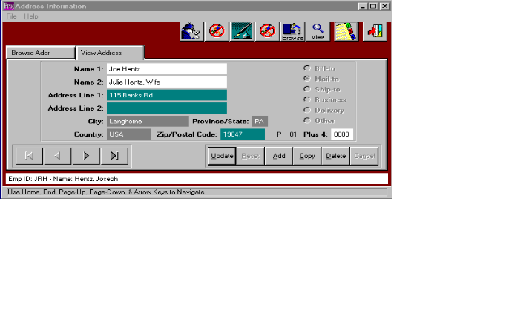

EMPLOYEE BROWSER - F9 KEY, VIEW ADDRESS ICON

To add, change, delete or view an employee address or fax number in the employees address directory, first select the employee from the Employee Browser. Next, press the F9 KEY or click the icon with the perforated mailing labels. Then click the ADD button or press alternate and letter A together. To move from field to field, as with all Windows-based programs, the TAB key should be utilized. Many addresses may be created for an individual employee such as bill to mail to, ship to, business delivery or other. An existing employee address may be changed by pressing the UPDATE button. To copy an employee, press the COPY button, then change the information for the new employee address. To delete an existing employee address, select the address from the browser screen, then press the DELETE button. The left and right ARROW buttons at the bottom on the screen, will search for the first address, the previous address, next address and last address respectively. The ENTER key or the SAVE button are used to save the employee addresses.

ADVANCED SOFTWARE SERVICES, INC
MACHINE TRANSACTIONS – BROWSE TRANSACTIONS
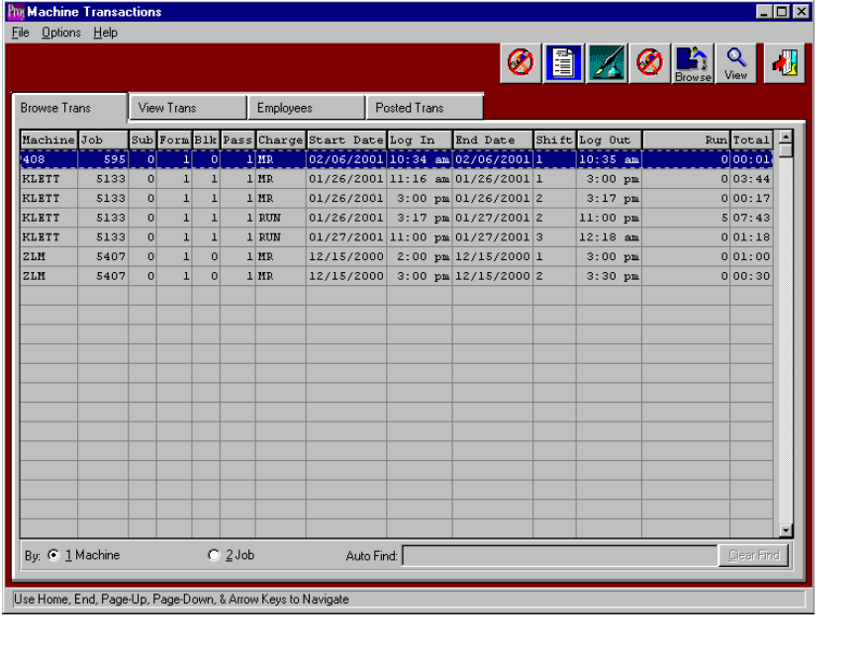

MACHINE TRANSACTIOIN BROWSER

The Machine Transaction Browser shows a list of unposted machine transactions, which may be sorted by the machine code or the job number. Once a machine transaction is highlighted on the screen, simply double click with your mouse or press the ENTER KEY to view or change the employee data. The browser is very similar to the F5 function key which Advantzware users are familiar with using. To sort by the machine code or job number, simply check the appropriate field at the bottom of the browser and the list will be resorted in that order. To find a particular machine transaction, the AUTO FIND block at the bottom of the browser provides an alpha numeric search capability by typing a few characters and pressing the ENTER KEY. The Machine Transaction browser shows the machine code, job number, form No., blank number, printing press pass number, machine charge code, starting date, log in time, the ending date, shift number, the log out time, run the quantity produced and total hours for the machine transaction.

The icons at the top of the browser provided additional capabilities. The F3 key, represented by an icon of a turning page will provide a list of machines, which may be printed or viewed on the screen. The F4 Key, represented by the icon with the fountain pen provides notes for each machine transaction. Each note records the user initials, date, and description of the note and a full-page of text for each note. Unlimited notes may be defined for each record. The F5 Key provides for miscellaneous fields. The F6 key or Browse icon will provide an immediate access to the browser by employee number. The F7 key or View icon provides a machine list as a quick reference list. The F12 key, represented by the open door is the equivalent of escape or exit.

The other folders listed on the machine transaction browser screen provide the ability to add, change, delete and copy the machine transactions information including the starting date, ending date, shift number, time started, time ended, machine charge code, run the quantity produced and the quantity wasted.
ADVANCED SOFTWARE SERVICES, INC
EMPLOYEES VIEW TRANSACTION
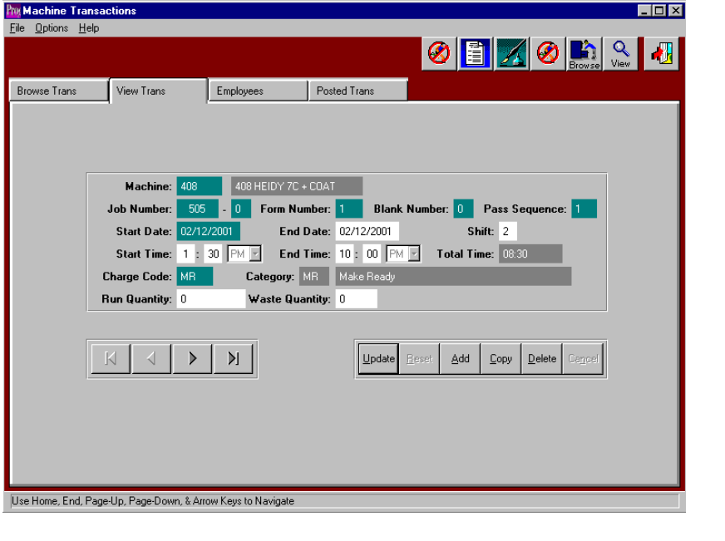

MACHINE TRANSACTION BROWSER - VIEW TRANSACTIONS FOLDER

To add, change, delete, or view an unposted machine transaction, the folder called VIEW TRANSACTION must be selected. The only information that may be changed for a machine transaction is the ending date, shift number, starting time, ending time, charge code, run quantity produced and quantity wasted. If the machine code or job number must be changed, then the entire transaction must be deleted and a new transaction created. To add a new transaction, click the ADD button or press alternate and letter A together. To move from field to field, as with all Windows-based programs, the TAB key should be utilized. The F1 KEY provides a look up to find a date by utilizing at electronic calendar. Press the UPDATE button to modify the machine transaction information. To copy a machine transaction, press the COPY button, then change the information for the new transaction. To delete an existing machine transaction, select the transaction from the machine transaction browser screen, the press the DELETE button. The left and right ARROW buttons at the bottom on the screen, will search for the first machine transaction, the previous transaction, next transaction and last transaction respectively. The ENTER key or the SAVE button are used to save the new machine transaction information.

ADVANCED SOFTWARE SERVICES, INC
EMPLOYEES BY MACHINE
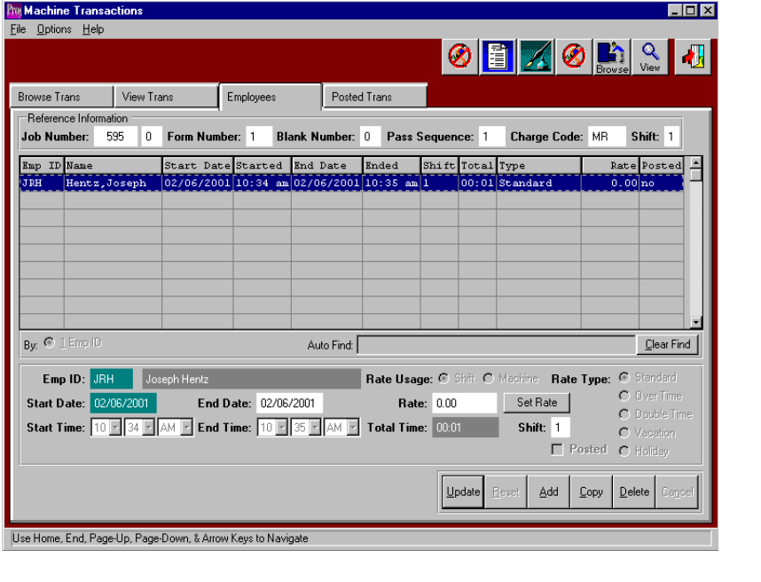

MACHINE TRANSACTION - EMPLOYEE TRANSACTIONS BY MACHINE FOLDER

This browser shows employee transactions for a particular machine transaction. All employees that are logged into that machine when the job data collection is added will automatically output to the employee transaction file for each machine transaction. To add, change, delete, or view an non-posted machine transaction for individual employees, the folder called EMPLOYEES must be selected, after or selecting the appropriate machine transaction. The only information that may be changed for a machine transaction is the ending date, shift number, starting time, ending time and the employee's hourly rate. The SET RATE button in conjunction with the rate price may be utilized to calculate the hourly rate for the employee. The rate types available include standard rate, over time rate, double time rate, vacation rate and holiday rate, which are defined in the employee file maintenance program. If the employee code or starting date must be changed, then the entire transaction must be deleted and a new transaction created. To add a new transaction, click the ADD button or press alternate and letter A together. To move from field to field, as with all Windows-based programs, the TAB key should be utilized. The F1 KEY provides a look up to find a date by utilizing at electronic calendar. Press the UPDATE button to modify the employee transaction information. To copy a machine's transaction, press the COPY button, then change the information for the new transaction. To delete an existing employee’s machine transaction, select the transaction from the machine transaction browser screen, the press the EMPLOYEE's folder, then highlight the employee transaction and press the DELETE button. The left and right ARROW buttons at the bottom on the screen, will search for the first employee transaction, the previous employee a transaction, next employee transaction and last employee transaction respectively. The ENTER key or the SAVE button are used to save the new or updated employee machine transaction information.
ADVANCED SOFTWARE SERVICES, INC
EMPLOYEE POST TRANSACTIONS
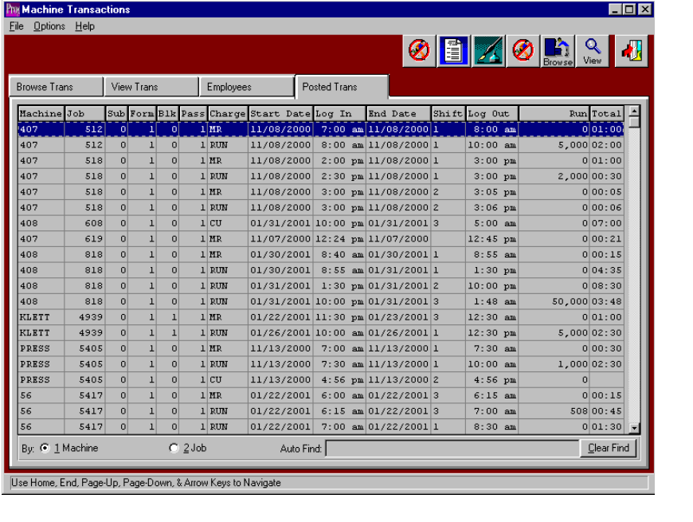

MACHINE TRANSACTIOIN BROWSER - POSTED TRANSACTIONS FOLDER

The Machine Transaction Browser shows a list of posted machine transactions, which may be sorted by the machine code or the job number, but cannot be changed. The browser is very similar to the F5 function key which Advantzware users are familiar with using. To sort by the machine code or job number, simply check the appropriate field at the bottom of the browser and the list will be resorted in that order. To find a particular machine transaction, the AUTO FIND block at the bottom of the browser provides an alpha numeric search capability by typing a few characters and pressing the ENTER KEY. The posted Machine Transaction browser shows the machine code, job number, form number, blank number, printing press pass number, machine charge code, starting date, log in time, the ending date, shift number, the log out time, the run quantity produced and total hours for the machine transaction.

The icons at the top of the browser provided additional capabilities. The F3 key, represented by an icon of a turning page will provide a list of employee, which may be printed or viewed on the screen. The F4 Key, represented by the icon with the fountain pen provides notes for each machine transaction. Each note records the user initials, date, and description of the note and a full-page of text for each note. Unlimited notes may be defined for each record. The F5 Key provides for miscellaneous fields. The F6 key or Browse icon will provide an immediate access to the browser by machine code. The F7 key or View icon provides a machine list as a quick reference list. The F12 key, represented by the open door is the equivalent of escape or exit.

ADVANCED SOFTWARE SERVICES, INC
BROWSE EMPLOYEE TRANSACTIONS
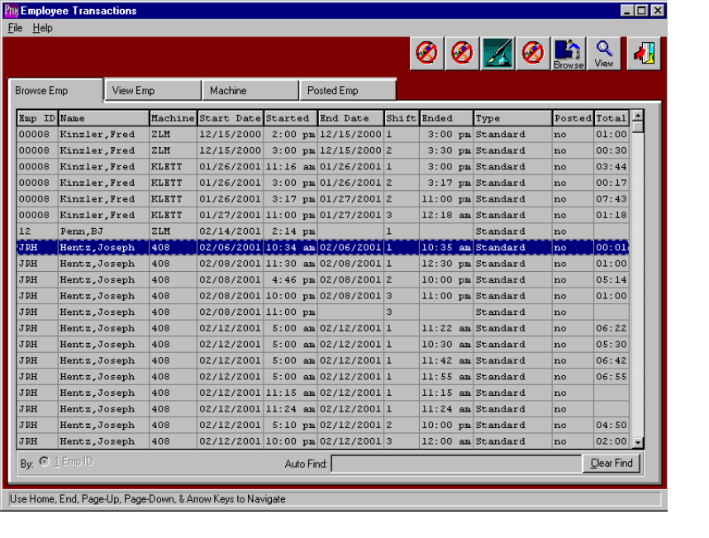

EMPLOYEE TRANSACTIOIN BROWSER

The Employee Transaction Browser shows a list of unposted employee transactions, which are sorted by the employee code. Once an employee transaction is highlighted on the screen, simply double click with your mouse or press the ENTER KEY to view or change the employee data. The browser is very similar to the F5 function key which Advantzware users are familiar with using. To sort by the employee code, simply check the appropriate field at the bottom of the browser and the list will be resorted in that order. To find a particular employee transaction, the AUTO FIND block at the bottom of the browser provides an alpha numeric search capability by typing a few characters and pressing the ENTER KEY. The employee Transaction browser shows the employee code, employee name, machine code, starting date, time started, the ending date, the log out time, shift number, labor rate type, the run quantity produced, the total hours for the employee transaction and the posted for unposted flag.

The icons at the top of the browser provided additional capabilities. The F4 Key, represented by the icon with the fountain pen provides notes for each employee transaction. Each note records the user initials, date, and description of the note and a full-page of text for each note. Unlimited notes may be defined for each record. The F5 Key provides for miscellaneous fields. The F6 key or Browse icon will provide an immediate access to the browser by employee number. The F7 key or View icon provides a view of the highlighted employee as a quick reference. The F12 key, represented by the open door is the equivalent of escape or exit.

ADVANCED SOFTWARE SERVICES, INC
VIEW EMPLOYEE TRANSACTIONS
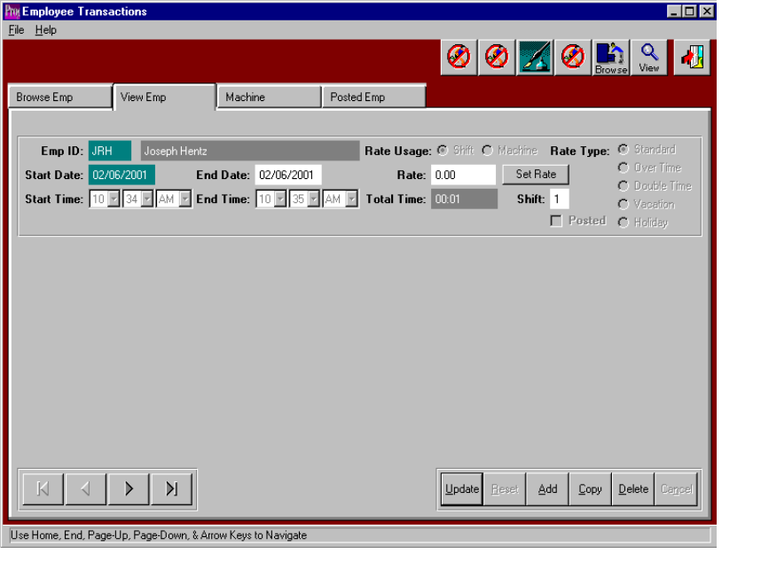

EMPLOYEE TRANSACTION BROWSER - VIEW TRANSACTIONS FOLDER

To add, change, delete, or view an unposted employee transaction, the folder called VIEW EMPLOYEE must be selected. The only information that may be changed for an employee transaction is the ending date, shift number, starting time, ending time and the employee's labor rate. The SET RATE button in conjunction with the rate price may be utilized to calculate the hourly rate for the employee. The rate types available include standard rate, over time rate, double time rate, vacation rate and holiday rate, which are defined in the employee file maintenance program. If the employee code or starting date must be changed, then the entire transaction must be deleted and a new transaction created. To add a new transaction, click the ADD button or press alternate and letter A together. To move from field to field, as with all Windows-based programs, the TAB key should be utilized. The F1 KEY provides a look up to find a date by utilizing at electronic calendar. Press the UPDATE button to modify the employee transaction information. To copy an employee transaction, press the COPY button, then change the information for the new transaction. To delete an existing employee transaction, select the transaction from the employee transaction browser screen, the press the DELETE button. The left and right ARROW buttons at the bottom on the screen, will search for the first employee transaction, the previous transaction, next transaction and last transaction respectively. The ENTER key or the SAVE button are used to save the new employee transaction information.
ADVANCED SOFTWARE SERVICES, INC
EMPLOYEE MACHINE TRANSACTIONS

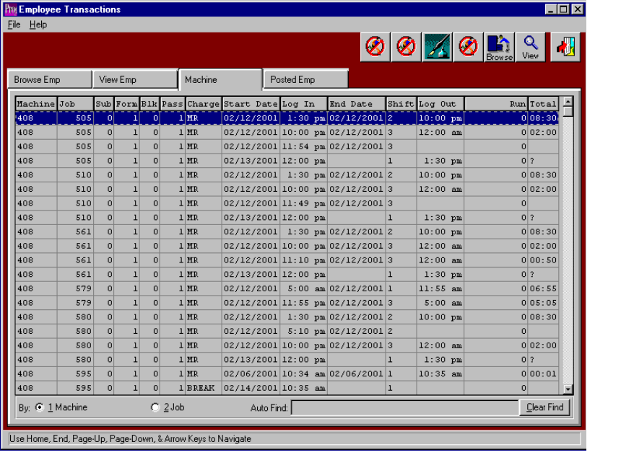

EMPLOYEE TRANSACTION - MACHINE TRANSACTIONS FOR EMPLOYEES

To view an unposted machine transaction for individual employee, the folder called MACHINE must be selected, after selecting the appropriate employee transaction from employee browser. No information may be changed for an employee's machine transaction. The browser is very similar to the F5 function key which Advantzware users are familiar with using. To sort by the machine code or job number, simply check the appropriate field at the bottom of the browser and the list will be resorted in that order. To find a particular machine transaction, the AUTO FIND block at the bottom of the browser provides an alpha numeric search capability by typing a few characters and pressing the ENTER KEY. The Machine Transaction browser shows an individual employees machine code, job number, form number, blank number, printing press pass number, machine charge code, starting date, log in time, the ending date, shift number, the log out time, run the quantity produced and total hours for the machine transaction. To change the transaction, the menu called MACHINE TRANSACTIONS under file maintenance should be selected.

ADVANCED SOFTWARE SERVICES, INC
EMPLOYEE POSTED TRANSACTIONS
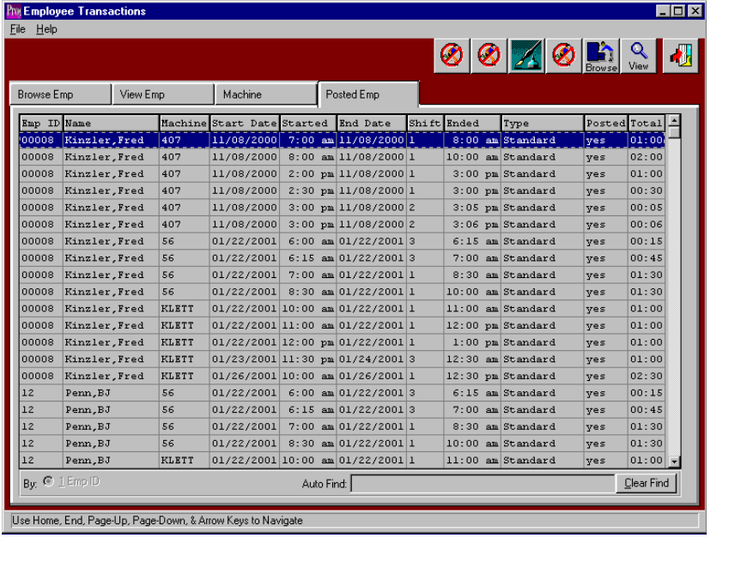

EMPLOYEE TRANSACTIOIN BROWSER - POSTED TRANSACTIONS

The employee Transaction Browser shows a list of posted employee transactions for each machine, which are sorted by the employee code, but cannot be changed. The browser is very similar to the F5 function key which Advantzware users are familiar with using. To find a particular employee transaction, the AUTO FIND block at the bottom of the browser provides an alpha numeric search capability by typing a few characters and pressing the ENTER KEY. The posted employee Transaction browser shows the employee code, employee name, machine number, starting date, log in time, the ending date, shift number, the log out time, the labor hourly rate type, the total hours for the employee transaction and the posted for unposted flag.

The icons at the top of the browser provided additional capabilities. The F4 Key, represented by the icon with the fountain pen provides notes for each employee transaction. Each note records the user initials, date, and description of the note and a full-page of text for each note. Unlimited notes may be defined for each record. The F5 Key provides for miscellaneous fields. The F6 key or Browse icon will provide an immediate access to the browser by employee number. The F7 key or View icon provides a view to the highlighted employee as a quick reference. The F12 key, represented by the open door is the equivalent of escape or exit.

ADVANCED SOFTWARE SERVICES, INC
COMPLETED MACHINE JOBS – BROWSE MODE
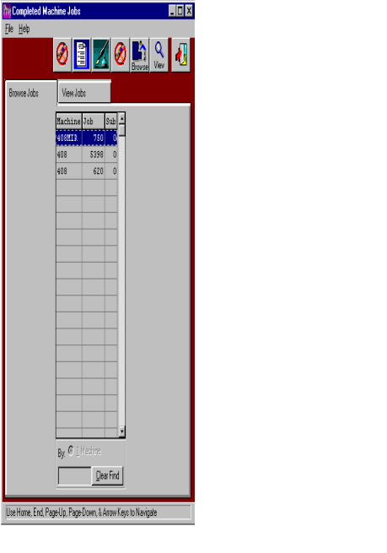

COMPLETED MACHINE JOBS BROWSER

The completed machine by job browser shows a list of machine transactions for each job number, which are sorted by the machine code, but cannot be changed. The browser is very similar to the F5 function key which Advantzware users are familiar with using. To find a particular employee transaction, the AUTO FIND block at the bottom of the browser provides an alpha numeric search capability by typing a few characters and pressing the ENTER KEY. The completed machine by job browser shows the machine number and to number. The icons at the top of the browser provided additional capabilities. The F3 key, represented by an icon of a turning page will provide a list of machines which may be printed or viewed on the screen. The F4 Key, represented by the icon with the fountain pen provides notes for each machine. Each note records the users initials, date, description of the note and a full-page of text for each note. Unlimited notes may be defined for each record. The F5 Key provides for miscellaneous fields. The F6 key or Browse icon will provide an immediate access to the browser by machine. The F7 key or View icon provides a view to the highlighted machine as a quick reference. The F12 key, represented by the open door is the equivalent of escape or exit.

ADVANCED SOFTWARE SERVICES, INC
COMPLETD MACHINE JOBS – VIEW MODE
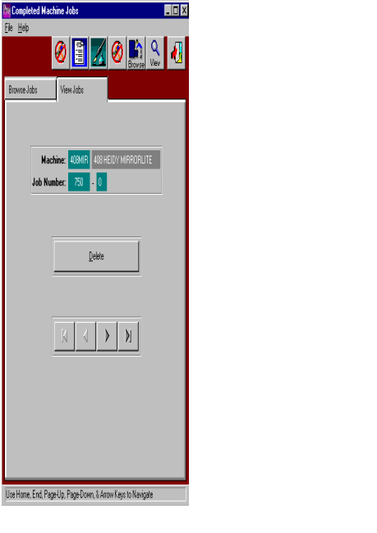

COMPLETED MACHINE JOBS - VIEW JOBS

To delete a completed machine transaction the folder called VIEW JOBS must be selected after selecting the machine from the browse jobs folder. To delete an existing machine transaction, select the transaction from the browse jobs folder, then press the DELETE button. The ENTER key or the SAVE button are used to save the new employee transaction information.
ADVANCED SOFTWARE SERVICES, INC
JOB BROWSE SEQUENCE

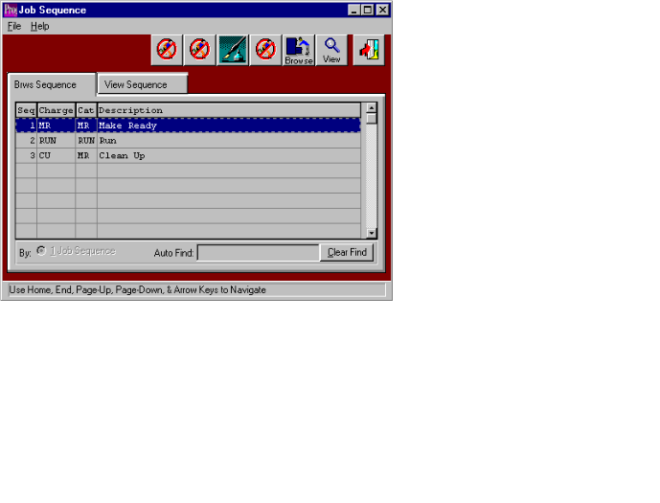

JOB SEQUENCE BROWSER

The job sequence browser shows a list of the normal manufacturing steps that a machine will process for a job. The charge codes list serves as a default when assigning machine charge codes. This list of manufacturing steps speeds the plant floor data collection because the operator is no longer required to enter the machine charge codes. In addition, the program remembers the last operation performed on a machine and will automatically transfer the next charge code for the machine operation. Once machine charge code is highlighted on the screen, simply double click with your mouse or press the ENTER KEY to view or change the machine charge code data. The browser is very similar to the F5 function key which Advantzware users are familiar with using. To find a particular job sequence or machine charge code, the AUTO FIND block at the bottom of the browser provides an alpha numeric search capability by typing a few characters and pressing the ENTER KEY. The job sequence browser shows the sequence number, machine charge code, job costing category for the charge code and the description for the labor charge.

The icons at the top of the browser provided additional capabilities. The F4 Key, represented by the icon with the fountain pen provides notes for each employee transaction. Each note records the user initials, date, and description of the note and a full-page of text for each note. Unlimited notes may be defined for each record. The F5 Key provides for miscellaneous fields. The F6 key or Browse icon will provide an immediate access to the browser by job sequence. The F7 key or View icon will provide immediate access to the viewer. The F12 key, represented by the open door is the equivalent of escape or exit.

ADVANCED SOFTWARE SERVICES, INC
VIEW SEQUENCE

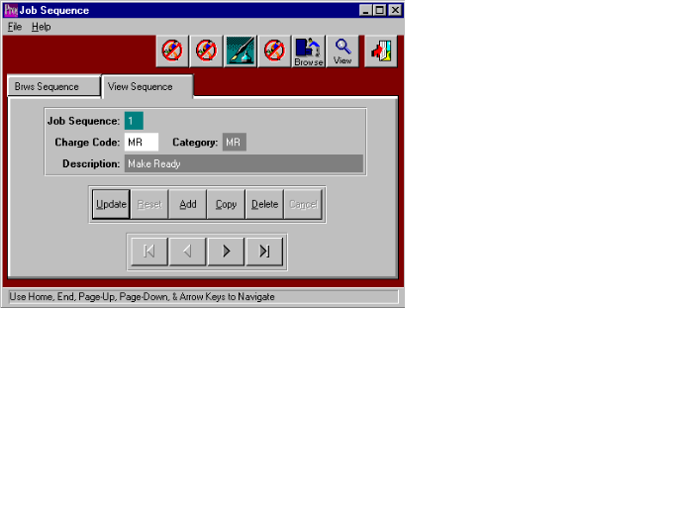

JOB SEQUENCE BROWSER - VIEW SEQUENCE

To add, change, delete, or view a machine charge code sequence, the folder called VIEW SEQUENCE must be selected. The only information that may be changed for a machine charge code sequence is the charge code, category and the description. If the employee code or starting date must be changed, then the entire transaction must be deleted and a new transaction created. To add a new transaction, click the ADD button or press alternate and letter A together. To move from field to field, as with all Windows-based programs, the TAB key should be utilized. The F1 KEY provides a look up to find a date by utilizing at electronic calendar. Press the UPDATE button to modify the machine charge code sequence information. To copy a charge code sequence, press the COPY button, then change the information for the new transaction. To delete an existing charge code sequence, select the transaction from the job sequence browser screen, the press the DELETE button. The left and right ARROW buttons at the bottom on the screen, will search for the first machine charge code sequence, the previous sequence, next sequence and the last charge code sequence respectively. The ENTER key or the SAVE button are used to save the machine charge code sequence information.

ADVANCED SOFTWARE SERVICES, INC
SHIFTS BROWSER
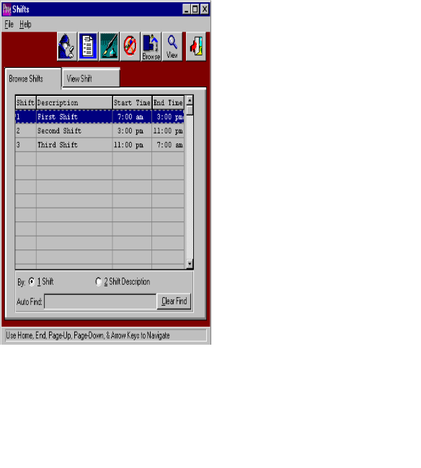

SHIFTS BROWSER

The job shifts browser shows a list of the production shifts for the entire manufacturing plant. This file provides the ability to have shifts with different start and stop times or each machine or departmental center. For example, shifts could be defined for the glowing department starting at 5 in the morning, whereas shifts for the printing department could begin at 7 in the morning. This list of manufacturing shifts are used when defining shares for a machine in the machine file. During plant floor data collection the system will automatically calculates the shift number based on the machine transaction times which are entered by the operator. To select a shift, highlight the shift on the screen, then simply double click with your mouse or press the ENTER KEY to view or change the shift code data. The browser is very similar to the F5 function key which Advantzware users are familiar with using. To find a particular shift, the AUTO FIND block at the bottom of the browser provides an alpha numeric search capability by typing a few characters and pressing the ENTER KEY. The shifts browser shows the shift number, description of the shift, starting time of the shift and the ending time of the shift.

The icons at the top of the browser provided additional capabilities. The F2 key, represented by the icon of the little man with a magnifying glass provides a search capability by shift. The F3 key, represented by an icon of a turning page will provide a list of employee, which may be printed or viewed on the screen. The F4 Key, represented by the icon with the fountain pen provides notes for each employee transaction. Each note records the user initials, date, and description of the note and a full-page of text for each note. Unlimited notes may be defined for each record. The F5 Key provides for miscellaneous fields. The F6 key or Browse icon will provide an immediate access to the browser by employee number. The F7 key or View icon provides a shift list as a quick reference list. The F12 key, represented by the open door is the equivalent of escape or exit.
ADVANCED SOFTWARE SERVICES, INC
VIEW SHIFTS
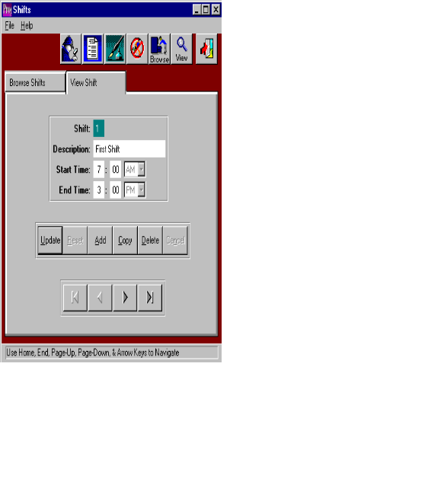

SHIFTS BROWSER - VIEW SHIFT

To add, change, delete, or view a shift for the plant, the folder called VIEW SHIFT must be selected. The only information that may be changed for a shift is the shift description, starting time of the shift and ending time of the shift. To add a new shift, click the ADD button or press alternate and letter A together. To move from field to field, as with all Windows-based programs, the TAB key should be utilized. The F1 KEY provides a look up to find a date by utilizing at electronic calendar. Press the UPDATE button to modify the shift information. To copy a shift for the plant, press the COPY button, then change the information for the new shift. To delete an existing shift, select the shift from the shift browser screen, then press the DELETE button. The left and right ARROW buttons at the bottom on the screen, will search for the first shift, the previous shift, next shift and the last shift respectively. The ENTER key or the SAVE button are used to save the shift information.
ADVANCED SOFTWARE SERVICES, INC
MACHINE ASSIGNED CHARGE CODES
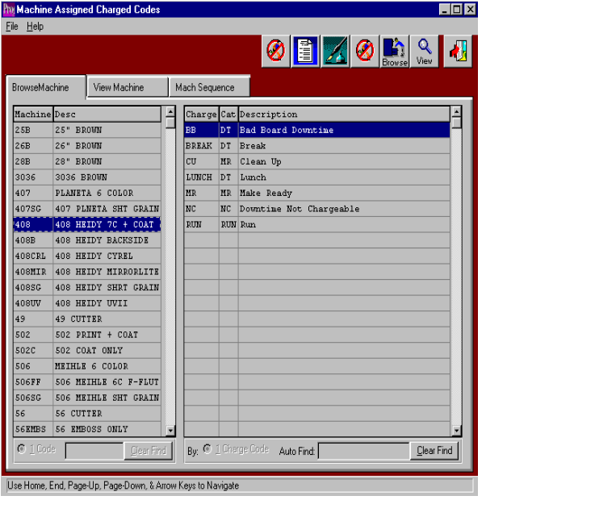

MACHINE ASSIGNED CHARGE CODES BROWSER

The machine assigned charge codes browser shows a list of machines and labor charge codes. This list of manufacturing charge codes must be defined for each machine. Examples include make ready, run, lunch, downtime, no work, bad board, etc. The machine charge codes are presented as buttons during the plant floor data collection process. This speeds floor reporting because the operator is no longer required to enter the machine charge codes. In addition, the program remembers the last operation performed on a machine and will automatically transfer the next charge code for the machine operation. Once machine charge code is highlighted on the screen, simply double click with your mouse or press the ENTER KEY to view or change the machine charge code data. The browser is very similar to the F5 function key which Advantzware users are familiar with using. To find a particular job sequence or machine charge code, the AUTO FIND block at the bottom of the browser provides an alpha numeric search capability by typing a few characters and pressing the ENTER KEY. The machine assigned charge codes browser shows the machine number, machine description, machine charge code, job costing category for the charge code and the description for the labor charge code.

The icons at the top of the browser provided additional capabilities. The F3 key, represented by an icon of a turning page will provide a list of charge codes, which may be printed or viewed on the screen. The F4 Key, represented by the icon with the fountain pen provides notes for each charge code. Each note records the user initials, date, and description of the note and a full-page of text for each note. Unlimited notes may be defined for each record. The F5 Key provides for miscellaneous fields. The F6 key or Browse icon will provide an immediate access to the browser by charge code. The F7 key or View icon will provide immediate access to the viewer. The F12 key, represented by the open door is the equivalent of escape or exit.

ADVANCED SOFTWARE SERVICES, INC
MACHINE ASSIGNED CHARGE CODES

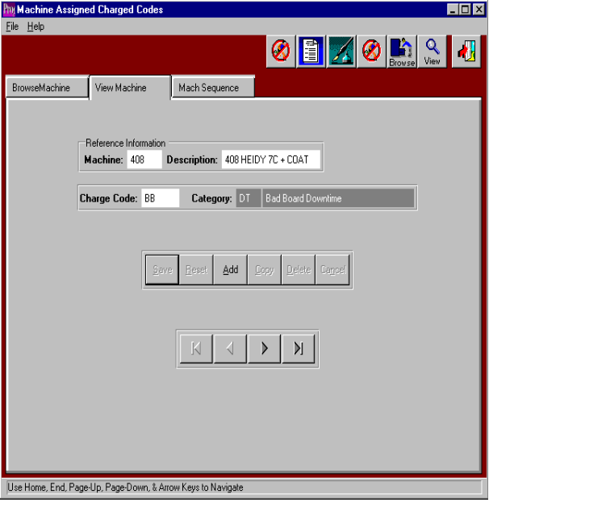

MACHINE ASSIGNED CHARGE CODES BROWSER - VIEW MACHINE

To add, change, delete, or view a machine charge code, the folder called VIEW MACHINE must be selected. The only information that may be changed for a machine is the charge code and the description. To add a new transaction, click the ADD button or press alternate and letter A together. To move from field to field, as with all Windows-based programs, the TAB key should be utilized. The F1 KEY provides a look up to find a date by utilizing at electronic calendar. Press the UPDATE button to modify the machine charge code information. To copy a charge code, press the COPY button, then change the information for the new transaction. To delete an existing charge code, select the machine from the machine assigned charge code browser screen, the press the DELETE button. The left and right ARROW buttons at the bottom on the screen, will search for the first machine charge code, the previous charge code, next machine charge code and the last charge code respectively. The ENTER key or the SAVE button are used to save the machine charge code information.
Charge code information.
ADVANCED SOFTWARE SERVICES, INC
MACHINE ASSIGNED CHARGE CODES MATCH SEQUENCE

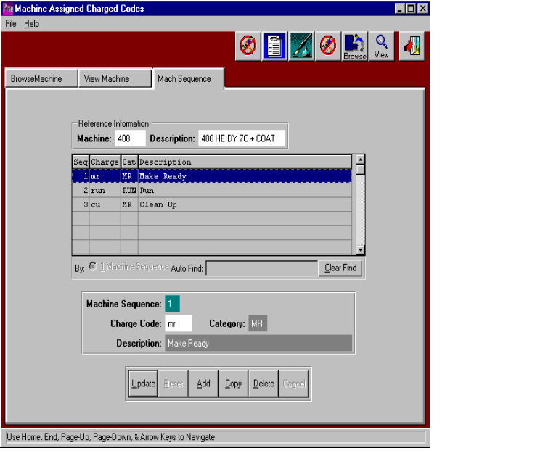

MACHINE ASSIGNED CHARGE CODES BROWSER - MACHINE SEQUENCE FOLDER

To add, change, delete, or view a machine charge code sequence, the folder called MACHINE SEQUENCE must be selected. The only information that may be changed for a machine is the charge code sequence number. To add a new sequence transaction, click the ADD button or press alternate and letter A together. To move from field to field, as with all Windows-based programs, the TAB key should be utilized. The F1 KEY provides a look up to find a date by utilizing at electronic calendar. Press the UPDATE button to modify the machine charge code sequence information. To copy a charge code, press the COPY button, then change the information for the new transaction. To delete an existing charge code, select the machine from the machine assigned charge code browser screen, the press the DELETE button. The left and right ARROW buttons at the bottom on the screen, will search for the first machine charge code sequence, the previous charge code sequence, next machine charge code sequence and the last charge code sequence respectively. The ENTER key or the SAVE button are used to save the machine charge code sequence information.

ADVANCED SOFTWARE SERVICES, INC
MACHINE ASSIGNED SHIFTS
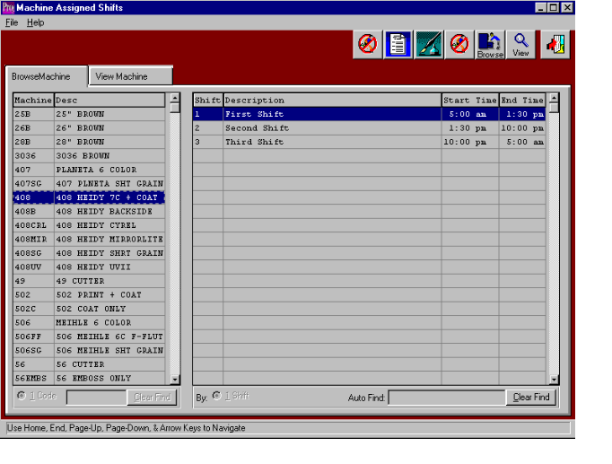

MACHINE ASSIGNED SHIFTS BROWSER

The machine assigned shifts browser shows a list of the production shifts for a particular machine. This file is not necessary if all the machines in the plant run on the same shift schedule. Under that circumstance the shift file would be utilized to determine the shift number during plant data collection. This file provides the ability to have shifts with different start and stop times or each machine or departmental center. For example, shifts could be defined for the glowing department starting at 5 in the morning, whereas shifts for the printing department could begin at 7 in the morning. This list of manufacturing shifts are used when defining shares for a machine in the machine file. During plant floor data collection the system will automatically calculates the shift number based on the machine transaction times which are entered by the operator. To select a shift, highlight the shift on the screen, then simply double click with your mouse or press the ENTER KEY to view or change the shift code data. The browser is very similar to the F5 function key which Advantzware users are familiar with using. To find a particular shift, the AUTO FIND block at the bottom of the browser provides an alpha numeric search capability by typing a few characters and pressing the ENTER KEY. The shifts browser shows the shift number, description of the shift, starting time of the shift and the ending time of the shift.

The icons at the top of the browser provided additional capabilities. The F3 key, represented by an icon of a turning page will provide a list of machine, which may be printed or viewed on the screen. The F4 Key, represented by the icon with the fountain pen provides notes for each machine transaction. Each note records the user initials, date, and description of the note and a full-page of text for each note. Unlimited notes may be defined for each record. The F5 Key provides for miscellaneous fields. The F6 key or Browse icon will provide an immediate access to the browser by machine number. The F7 key or View icon provides a machine list as a quick reference list. The F12 key, represented by the open door is the equivalent of escape or exit.

ADVANCED SOFTWARE SERVICES, INC
MACHINE ASSIGNED SHIFTS
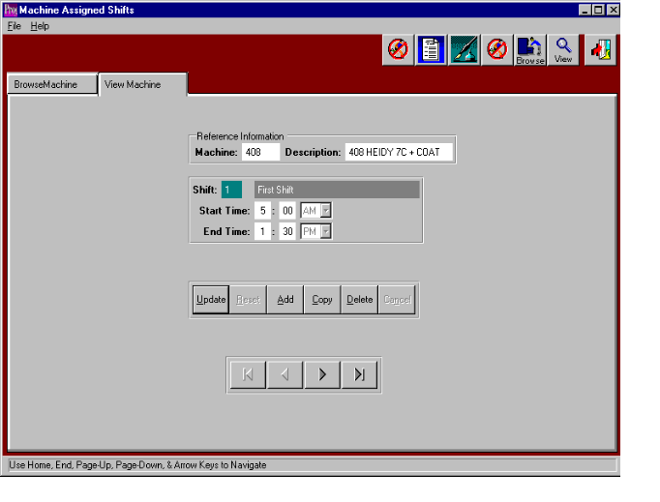

MACHINE ASSIGNED SHIFTS - VIEW MACHINE

To add, change, delete, or view a shift for the plant, the folder called VIEW MACHINE must be selected. The only information that may be changed for a machine shift is the shift's starting time of the shift and ending time of the shift. To add a new shift, click the ADD button or press alternate and letter A together. To move from field to field, as with all Windows-based programs, the TAB key should be utilized. Press the UPDATE button to modify the shift information. To copy a shift for the plant, press the COPY button, then change the information for the new shift. To delete an existing shift, select the shift from the shift browser screen, then press the DELETE button. The left and right ARROW buttons at the bottom on the screen, will search for the first shift, the previous shift, next shift and the last shift respectively. The ENTER key or the SAVE button are used to save the shift information.

ADVANCED SOFTWARE SERVICES, INC
EMPLOYEE DEFAULT RATES
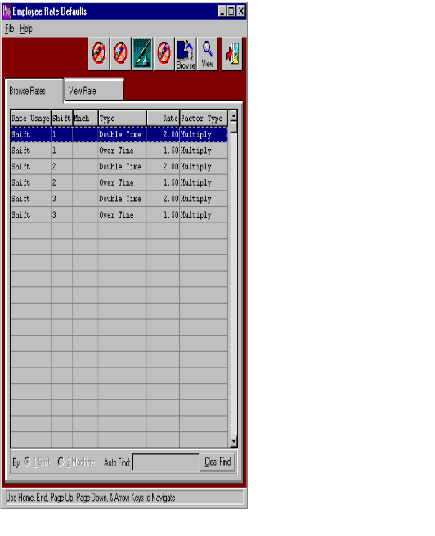

EMPLOYEE RATE DEFAULTS BROWSER

The hourly rates file serves to establish standard hourly labor rates for the entire company, therefore this file should be billed before adding new employees. Building this file will help to speed the data entry process of adding employees. Therefore, if numerous employees have the same labor rates the company labor rates defined in this file will serve as default of adding new employees.

The icons at the top of the browser provided additional capabilities. The F4 Key, represented by the icon with the fountain pen provides notes for each hourly rate such as when the hourly rate was first enacted. Each note records the user initials, date, and description of the note and a full-page of text for each note. Unlimited notes may be defined for each rate record. The F5 Key provides for miscellaneous fields. The F6 key or Browse icon will provide an immediate access to the browser by hourly rate. The F7 key or View icon provides a rate list as a quick reference list. The F12 key, represented by the open door is the equivalent of escape or exit.

ADVANCED SOFTWARE SERVICES, INC
EMPLOYEE DEFAULT RATES
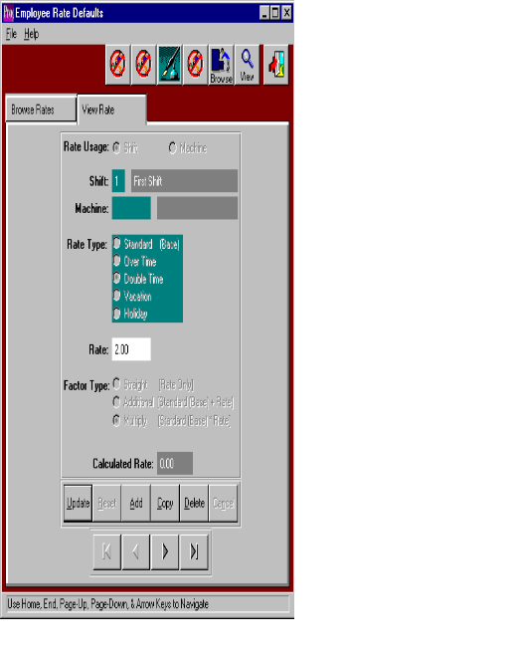

EMPLOYEE RATE DEFAULTS BROWSER - VIEW RATE

To add, change, delete, or view an employees standard hourly or salary pay rates, the folder called VIEW RATES must be selected after selecting an hourly rate. The pay rate browser will list the existing pay rates showing the rate usage (i.e. by machine or shift), shift number, machine code, rate type, hourly rate and factor type description. To add pay rates, click the ADD button or press the ALTERNATE key and letter A simultaneously. To move from field to field, as with all Windows-based programs, the TAB key should be utilized. Press the UPDATE button to modify an existing pay rate selected on the pay rate browser. To copy a pay rate, press the COPY button, then change the information for the new pay rate. To delete an existing hourly pay rate, select the rate from the rate browser screen, the press the DELETE button. The left and right ARROW buttons at the bottom on the screen, will search for the first pay rate, the previous pay rate, next pay rate and last pay rate. The ENTER key or the SAVE button are used to save the pay rate.

When adding or updating an hourly pay rate, many selections are available to help calculate the employees pay rate. The first field on the screen is the rate usage, which determines if the pay rate is for a particular machine or the pay rate is for the entire shift. If the employee has only one hourly rate for all machines that he operates, the rate usage should be set to shift. If the employee is paid different hourly rates depending on the machine, the rate usage should be set to machine. The shift field must be a valid shift defined in the shift file, therefore the F1 key may be used to display the valid shifts. The machine code is required only if the rate usage field is set to machine, whereby the employee's hourly rate will be defined for each particular machine. The rate type field is used to differentiate different hourly rates for the same employee. Available options are a standard rate, overtime rate, double time rate, vacation rate and a holiday rate. The hourly rate field is the dollar amount paid to the employee for the selected rate type. The F1 key on the rate field may be used to help calculate the hourly rate by displaying a worksheet browser. The user may enter the total dollar amount paid to the employee on a yearly, semi annual, quarterly, monthly, biweekly, weekly or daily basis. When the OK button is selected, total dollar amount will be divided by the payment period chosen to determine the hourly rate. For example, we could add $800 dollars in the amount field, click the weekly pay basis, press the OK and the rate of $20 per hour would transfer to the hourly rate field. The factor type field defines the multiplication factor for the pay rate. The options include a standard rate, additional rate and multiplied rate. The standard rate is equal to the hourly rate, the additional rate is a dollar amount added a standard rate and multiplied rate is the factor multiplied by the standard rate. The net result is the calculated rate which is used for costing the man hours labor times.

ADVANCED SOFTWARE SERVICES, INC
EMPLOYEE TYPES
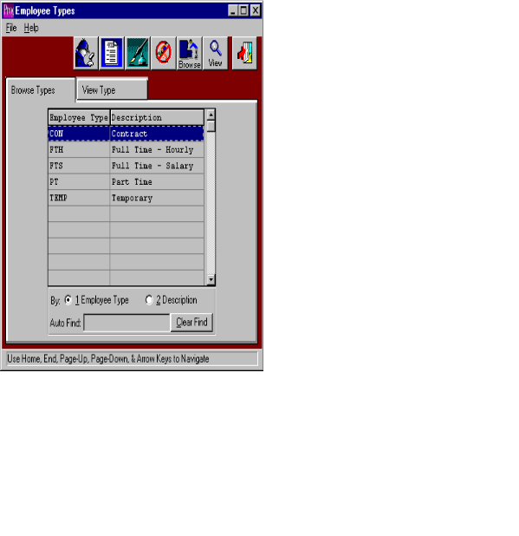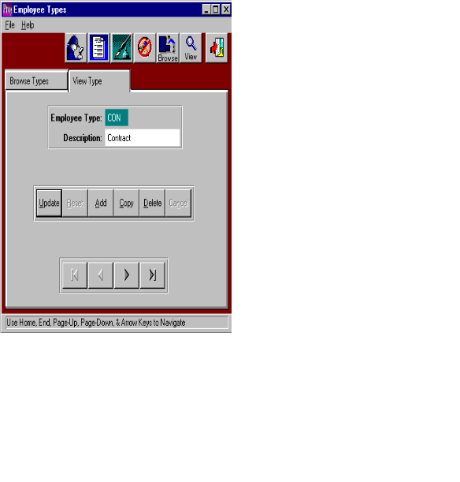

EMPLOYEE TYPES

The hourly rates file serves to establish standard employee types for the entire company, therefore this file should be billed before adding new employees. Building this file will help to speed the data entry process of adding employees. Therefore, if numerous employees have the same employee type, the company wide employee types defined in this file will serve as default of adding new employees.

The icons at the top of the browser provided additional capabilities. The F3 key, represented by the icon of the little man with a magnifying glass provides a search capability by an employee type. The F2 key, represented by an icon of a turning page will provide a list of employee types, which may be printed or viewed on the screen. The F4 Key, represented by the icon with the fountain pen provides notes for each employee type such as when the type was first enacted. Each note records the users initials, date, description of the note and a full-page of text for each note. Unlimited notes may be defined for each employee type record. The F5 Key provides for miscellaneous fields. The F6 key or Browse icon will provide an immediate access to the browser by employee type. The F7 key or View icon provides an employee type list as a quick reference list. The F12 key, represented by the open door is the equivalent of escape or exit.

